Qualification
BTEC Level 3 - Applied Science
Center Name | Center Registration No
ABC Horizon Academy | 91667
Student name | Assessor name
Sami Ben Ameur | Mr. Tareq ZAINALDIN
Unit Number/Name
Unit 28: Sustainable Energy
Assignment number and title | Submitted on
- Impact of use of fossil fuels  - Alternative energy sources  - Benefits and disadvantages of the use of renewable energy | 13/06/2026

Student Declaration


Student signature: Date: 13/06/2026

Contents
1- Impact of use of fossil fuels 6
1. Extraction 6
1.1 Coal: 6
1.2 Oil and gas: 7
2. Uses – power generation 10
A. Coal 10
B. Crude oil: 12
3. Environmental and ecological effects, Climate and human health: 14
2- Alternative energy sources 20
1. Factors that affect the efficiency of methods used to generate energy. 20
A. Capital costs 20
B. Operating and maintenance costs 20
C. Fuel and consumable costs 21
D. Environmental damage: 21
E. Lifetime and decommissioning 22
2. Technological advances improving efficiency relative to cost. 22
Innovative wind-turbine designs and materials 22
Advances in energy storage 23
Grid integration and digitalization 23
3. Levelized cost of electricity (LCOE). 23
A. The efficiency of different renewable energy sources comparison: 24
4. Factors that affect the efficiency of energy generation. 24
5. Describe the technologies used to generate renewable energy. 25
A. How technology is being used to generate renewable energy using solar, wind, water and biomass as fuels. 25
- Solar Energy Generation Technologies: 25
- Wind Energy Generation Technologies: 26
- Biomass Energy Generation Technologies: 27
- Water Energy Generation Technologies: 28
B. The advantages and disadvantages of using nuclear fuel. 29
3- Benefits and disadvantages of the use of renewable energy. 31
Introduction 31
1.1 Investment costs: 31
1.2 Operating costs: 33
1.3 Disposal of waste products: 33
1.4 Pollution: 33
1.5 Consistency/inconsistency of supply, storage of raw material 34
1.6 Efficiency: 35
1.7 Impact of the installation. 35
1.8 Noise and/or visual impact: 36
2. The benefits and disadvantages/detrimental effects renewable energy sources: 36
2.1 Solar energy: 36
2.2 Wind energy. 37
2.3 Hydroelectric energy: 37
2.4 Biomass energy: 38
2.5 Geothermal energy: 39
3. Comparison of Nuclear Energy and Biofuels: 39
3.1 Evaluation: 40
4. The advantages and disadvantages of renewable energy (Solar/Wind) 40
4.1 Solar Energy: 40
4.2 Wind Energy: 41
4.3 Energy Systems Comparative Evaluation: 41
4.3.1 Social Evaluation: 42
4.3.2 Environmental Evaluation: 42
4.3.3 Financial Evaluation: 42
4.3.4 Utility scale efficiency: 42
4.3.5 Conclusion: 42
References 43

Figure 1. Coal 6
Figure 2.Coal types 6
Figure 3.Coal Strip Mining 7
Figure 4.Mountain top mining 7
Figure 5.Offshore platforms 8
Figure 6.Onshore Drilling 8
Figure 7.Onshore-Offshore productions 9
Figure 8.Onshore-Offshore Startup location 9
Figure 9.Hydraulic fracturing 9
Figure 10.Steam coal power generation 10
Figure 11.Coking Coal 10
Figure 12.Cabon Fiber 11
Figure 15.Wind Blades design 22
Figure 16.Solar Energy Technology 26
Figure 17.Wind Energy Technology 27
Figure 18.Biomass Anaerobic Digestion 28
Figure 19.Biomass steam boiler 28
Figure 20.Hydo Power 29
Figure 21.Tidal Power 29
Figure 22.LCOE for solar and wind compared to fossil fuels 32
Figure 23.2023 Electricity Cost saving 32
Figure 24. Fossil Vs. Renewables 34

Table 1. Operating and maintenance costs 19
Table 2.LCOE Energy sources comparison 22
Table 3.Social,Environment and Financial efficiency 30
Table 4.Nuclear and Biofuels Energy Comparison 34
Table 5.Solar V.s Wind Advantages/ Disadvantages 36
Table 6.Wind energy Social, Environmental and Financial 36

Impact of use of fossil fuels
Introduction:
Studies in the field of fossil fuels are very important in the understanding of the development of ancient and modern civilizations. These fossil fuels were the primary source that assisted the industrial revolution in the invention of the steam engine in the 18th century, and they remain the primary lifeline of the world today and remain the primary reason for the political and economic supremacy of the world's major powers. The studies are highlighting the significance of the fossil fuels in the modern global economy, as well as environmental concerns and recent trends in the consumption of fossil fuels. Fossil fuels were formed from carbon-rich plant and animal matter millions of years ago, buried deep under the earth, where heat and pressure transformed them into a massive store of energy in the form of coal, oil, and natural gas.
As the fossil fuels are burned, the carbon and other greenhouse gases contained in them are released into the Earth's atmosphere. The excess buildup of greenhouse gases in the Earth's atmosphere is resulting in dramatic changes to the Earth's climate, and this will only get worse as more fossil fuels are burned.

Extraction
Where coal, oil and gas come from?

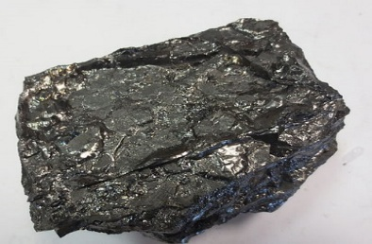
Coal:
Figure 1. Coal
Is a high-carbon fossil fuel formed through a process of burial and transformation that takes millions of years. Coal originates from organic matter in wet, swampy areas, where it undergoes biological decomposition followed by coalification Thermal and physical change. [1](Figure 1)
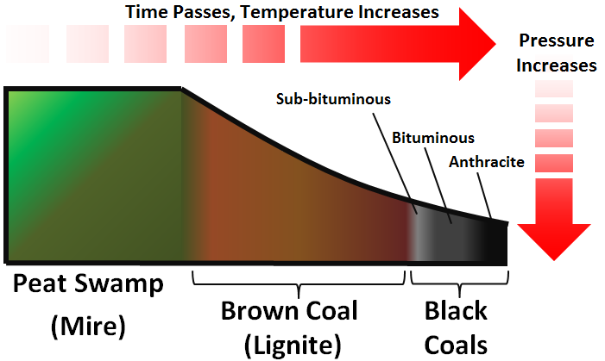
As the material is exposed to increasing heat and pressure over geological time, it transforms from peat to higher densities and higher grades from lignite to anthracite. This journey from sun-absorbing plants to solid fuel produces a highly concentrated energy source characterized by increased carbon content and low moisture. [1] (Figure 2)
Figure 2.Coal types
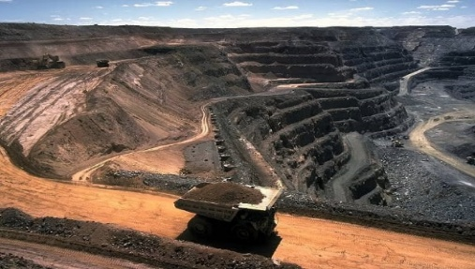
Strip mining: Allows for the extraction of 60% of the worlds coal in the present time. A thin upper layer of rock (usually just a few tens of meters) is removed to expose coal reservoirs 50-100 meters thick. These reservoirs of coal are referred to as coal seams. [1] (Figure3)
Figure 3.Coal Strip Mining
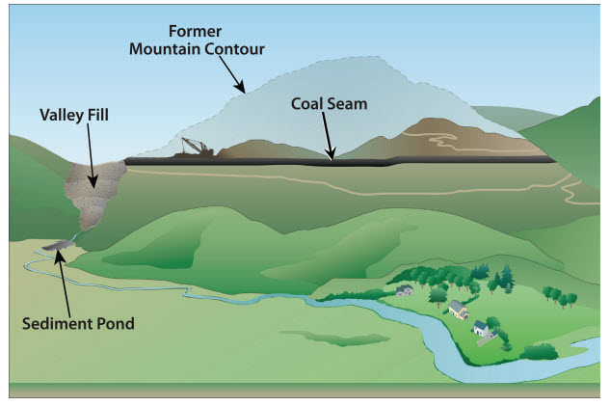
Mountain top mining: Entire top is removed in a series of parallel cuts, the top 300 meters or more of a coal containing mountain is removed via explosives to expose coal reservoirs 50 -100 meters thick. Once the coal is extracted the excess rubble is deposited in nearby valleys. The process is highly controversial for the drastic changes in topography, the practice of creating head-of-hollow-fills, or filling in valleys with mining debris, and for covering streams and disrupting ecosystems. [1] (Figure 4)
Figure 4.Mountain top mining
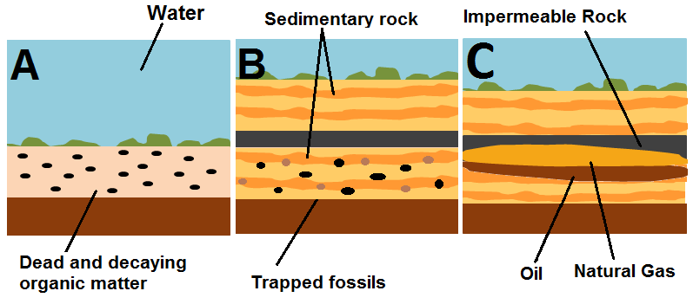
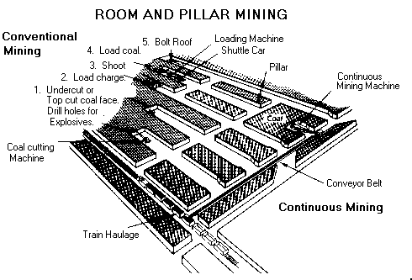
Underground mining: Underground coal mining primarily uses two methods: room-and-pillar and longwall techniques. Room-and-pillar involves cutting rooms while leaving pillars for support, with initial coal recovery of 30-50% that can increase to 90% with retreat mining. Longwall mining is a mechanized process using a shearer and hydraulic shields across wide coal faces, achieving 80% or higher recovery. Mining operations include unit operations for direct production (cutting, loading, hauling, roof support) and auxiliary operations for safety and infrastructure (ventilation, drainage, power). [1] (Figure 5)
Figure 6. Oil and gas origin
Figure 5. Underground mining
1.2 Oil and gas: Are known as fossil fuels because they are formed from the decomposition and pressurization of algae, plankton and other organisms. This process forms hydrocarbons, which are compounds consisting entirely of hydrogen and carbon that are powerful combustible fuels. Individual deposits of oil and gas can also contain other compounds, but it is the hydrocarbons that make them valuable. They are extracted from underground reservoirs and refined into fuels and petrochemicals. Oil is a liquid mixture, while natural gas is a flammable, colorless, odorless gaseous fuel. [2] (Figure 6)
Offshore drilling: Is the process of drilling into the ocean floor to access reservoir of oil and gas that located underneath oceans instead of reserves located on the mainland. The majority of new oil and gas extraction projects in 2024 are located in the oceans.
Types of Offshore Platforms:
Fixed Platforms: Used in shallow water up to 1,500 ft and greater, these stand on steel or concrete legs anchored to the seabed.
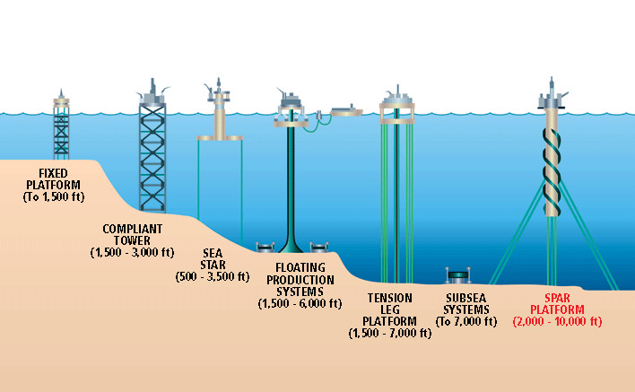
Floating Platforms: Used for deeper waters, including Tension Leg Platforms and drill ships, which are anchored by cables and can operate in depths exceeding 10,000 feet. [3](Figure 7)
Figure 5.Offshore platforms
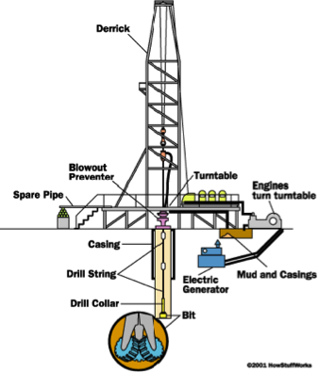
Onshore drilling: Onshore oil and gas extraction involves drilling vertical or directional boreholes on land using rotary rigs, following seismic surveys to locate underground reservoirs. A directional/Horizontal drilling allows drilling at angles to access reservoirs thousands of meters deep from the surface, reducing surface disruption. using a rotating drill bit cooled by mud. To prevent contamination of groundwater and stabilize the hole, steel pipes are inserted and cemented into place. The well is prepared for production by perforating the casing at the target depth to allow oil/gas to enter the wellbore. When pressure drops, mechanical pumps are installed to lift the oil. [2] (Figure 8)
Figure 6.Onshore Drilling
Offshore-Onshore production percentage: Discoveries have been growing in share of global discoveries per year, accounting for about 60% in the 2010s and then around 73% so far in the 2020s. [4](Figure 9)
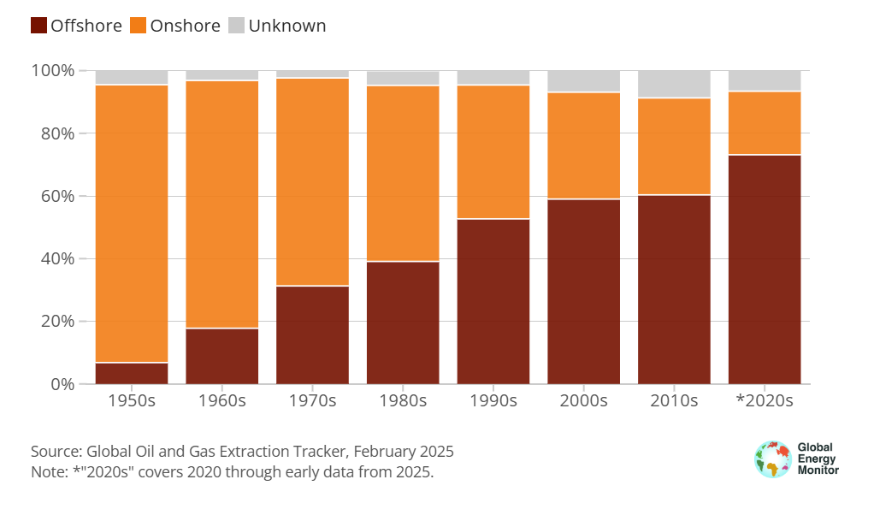
Figure 7.Onshore-Offshore productions

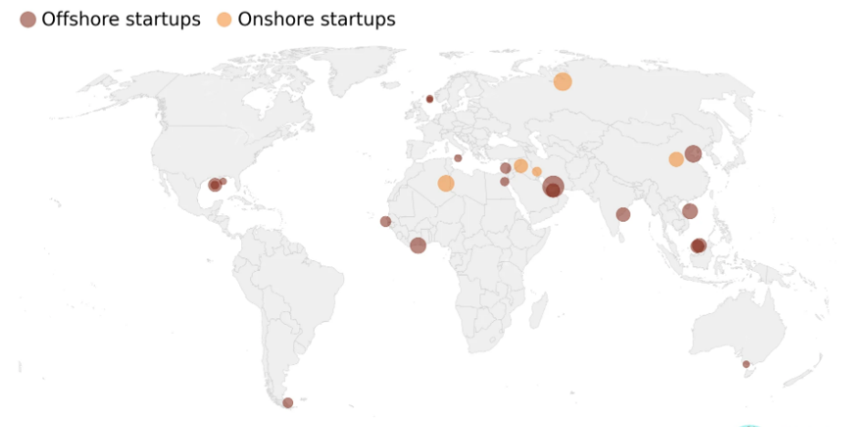
Offshore-Onshore startup locations:71% of new field startup volume located Offshore. (Figure 10)
Figure 8.Onshore-Offshore Startup location

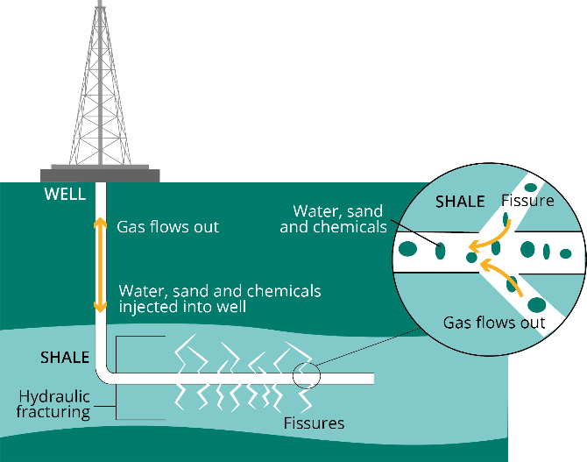
Hydraulic Fracturing: Commonly called fracking, is a technique used for extracting gas from deep underground. The drilling process, which is the same for any oil and gas extraction, starts with a borehole that is sealed with three layers of steel and cement that is drilled down through layers of rock and groundwater. When the drill reaches gas-rich shale rock, it turns and drills horizontally. Then the fracking process starts. By law, fracking can only be carried out at least as far as 1,000m from the surface. Tiny holes are created at the end of the steel pipe to allow the gas to flow into. large quantities of fluid are pumped down a borehole at high pressure. The fluid contains water and sand (99.5%) and chemical additives (0.5%). This causes tiny fractures to open in the shale rock. The sand holds open the cracks, allowing the gas to escape and rise through the borehole. The natural gas is then separated from the recovered fluid. [5](Figure 11)
Figure 9.Hydraulic fracturing

2. Uses – power generation
A. Coal: Coal remains a key component of global industrial infrastructure, serving as a fundamental source of energy and an important raw material for high-tech applications. While its role in power generation via steam coal and steel production via coking coal is relatively well documented, new technologies are utilizing coal derivatives in specialized fields. Below cited are the traditional and advanced applications of coal, including its conversion into carbon fibers for lightweight manufacturing and activated carbon for critical filtration and medical technologies. [6]
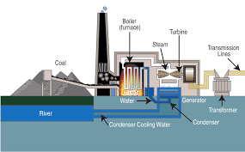
Steam Coal in Power Generation: Is a grade of coal used in electric power plants to generate steam to create electricity. Steam coals for power plants must meet quality and heating characteristics of the boiler design and for the design of pollution-control equipment at a power plant. To generate electricity the process involves many stages, coal is pulverized and burned in a boiler to produce intense heat. This heat converts water into high-pressure steam, then the steam drives a turbine connected to a generator, converting thermal energy into mechanical rotation and finally into electrical energy. [6] (Figure 12)
Figure 10.Steam coal power generation
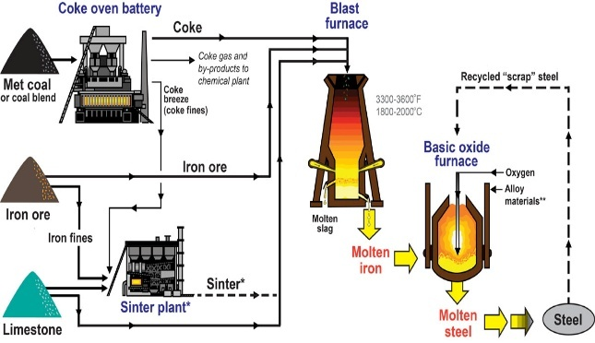
Coking coal (metallurgical coal): Coke, which is a fuel with high levels of carbon, usually made from coal, is utilized in the steel industry. It is used in blast and industrial furnaces, where it is mixed with iron ore to manufacture cast iron (an iron and carbon alloy that is a precursor of steel), by smelting reduction of iron oxide. [6] (Figure 13)
Figure 11.Coking Coal
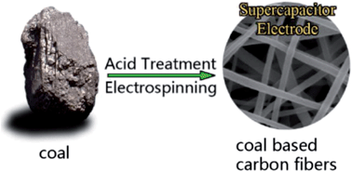
Carbon fiber: Coal is an essential precursor for carbon fiber, a high-strength, lightweight reinforcement material. Widely found in any number of products. Airplanes Golf clubs, tennis rackets, and bicycles have been lighter and sturdier. Wind turbine blades are often built with carbon fiber. Carbon fiber is produced by processing coal-derived pitches or chemical byproducts into thin, strong filaments. [6] (Figure 14)
Figure 12.Cabon Fiber
Activated carbon: Coal is a primary source for activated carbon, a highly porous material treated to have an extremely large surface area for adsorption. Used in domestic and industrial filters to remove toxins, chemicals, and impurities from drinking water and Vital for kidney dialysis machines, where it acts as a filter to cleanse the blood of waste products. Last but not least utilized in gas masks and industrial air scrubbers to neutralize harmful gases and pollutants. [6]
Use of by-products of coal (coal tar): The distillation of coal tar and the capture of coal combustion products provide essential precursors for pharmaceuticals, synthetic textiles, and sustainable construction. Following cited are the derivation of distillation of coal tar. [7]
Creosote Oil: This heavy oil fraction is primarily utilized as a wood preservative. Its fungicidal and insecticidal properties make it essential for treating railway sleepers, utility poles, and marine pilings, significantly extending the lifespan of timber infrastructure. [7]
Naphthalene: Best known as the primary ingredient in mothballs, naphthalene is also a vital intermediate in the production of phthalic anhydride, which is used to manufacture plastics, resins, and specialized fuels. [7]
Phenol and Benzene: These hydrocarbons are important in organic chemistry. Phenol is widely used to make resins and disinfectants, while benzene is used as a starting material for making a wide range of polymers, including nylon and synthetic rubber. [7]
Ammonia gas: During the carbonization of coal, nitrogen is released in the form of ammonia gas.
Ammonia is extracted and converted into ammonium salts (such as ammonium sulfate). While Nitric acid is processed into nitric acid, which is an essential ingredient in the production of high-quality explosives and nitrogen-rich agricultural fertilizers, linking coal production directly to global food security. [7]
Soaps, dyes, nylon: The chemical variations of coal tar allow for the synthesis of complex organic molecules. The dye revolution began with coal tar, providing the first vibrant synthetic pigments for the textile industry. As well coal-derived surfactants are used in industrial cleaning agents and specialized medicated soaps. While benzene is processed into adipic acid, a core component in the manufacture of nylon fibers, used in everything from apparel to industrial carpeting. [7]
Aspirin: In one important pharmaceutical application, coal tar derivatives such as phenol are converted into salicylic acid, the main precursor of aspirin. [7]
Coal combustion fly ash in cement making: This fine particulate (Fly Ash) is captured from exhaust gases. In the construction industry is used as a pozzolanic replacement for Portland cement.
Incorporating fly ash into concrete improves workability, increases long-term durability, and reduces the carbon footprint of cement production. [7]

B. Crude oil:
Fuels – gasoline, diesel, kerosene: The primary application of crude oil is the production of specialized fuels, which are separated based on their unique boiling points during the refining process to serve distinct industrial needs. Gasoline (petrol), a lightweight and volatile fraction, serves as the high-energy-density fuel required for internal combustion engines in light vehicles, while diesel provides a heavier, more energy-efficient alternative for the compression-ignition engines that power global freight, shipping, and heavy machinery. For the aviation sector, kerosene (jet fuel) is specifically refined to remain stable and functional at the high altitudes and extreme low temperatures characteristic of jet engine operation. [8]
Tar, asphalt, paraffin wax: Is heavy hydrocarbons that do not vaporize easily, providing the essential materials for global infrastructure and consumer goods. Asphalt and tar, the viscous residues of the refining process, serve as vital binding agents in road construction and roofing due to their waterproof and adhesive properties in civil engineering. Additionally, paraffin wax, a byproduct of lubricant refining, is utilized across diverse industries for food packaging, candle making, and as a durable moisture barrier for various industrial applications. [8]
Fertilizers, perfume, insecticides: Crude oil derivatives are chemically transformed into specialized agents that support global health and food systems, moving beyond energy and construction into the realm of life sciences. Petroleum-based naphtha and natural gas provide the essential hydrogen producing the nitrogenous fertilizers required to sustain global crop yields. Complex hydrocarbons are synthesized into insecticides and pesticides to protect agriculture from pests, while synthetic aromatic compounds derived from petroleum serve as the base for mass-produced perfumes and fragrances in the cosmetic industry. [8]
Plastics, PVC, Textiles: One of the major innovation uses of crude oil in the 20th century was the development of plastics and synthetic materials through the polymerization of refined gases like ethylene and propylene. This process yields versatile substances such as Polyvinyl Chloride (PVC), Acrylic or Polymethyl Methacrylate (PMMA), Polycarbonate (PC), Polyethylene (PE), Polypropylene (PP), Polyethylene Terephthalate (PETE or PET), Acrylonitrile-Butadiene-Styrene (ABS) a durable plastic essential for construction piping and chemical-resistant medical devices, alongside synthetic textiles like polyester and acrylic. These petroleum-derived polymers now providing unique levels of elasticity and durability that often surpass those of natural fibers. [8]
Natural gas: Generation of electricity: Relies on three primary turbine configurations, each balancing cost and efficiency differently. [8]
Open Cycle Gas Turbine, they generate electricity by burning gas to create hot air that directly drives a turbine. They are less efficient because they do not recover waste heat, making them best suited for short runs during peak demand. [8]
Combined Cycle Gas Turbine: This technology significantly boosts efficiency by adding a second stage to the Combined Cycle Gas Turbine process. The hot exhaust air exiting the engine is used to heat water and create steam, which then drives an additional steam turbine to generate more energy. Although more costly to build, Combined Cycle Gas are the dominant choice for steady, base-load power because of their superior efficiency. [8]
Combined Heat and Power, functioning similarly to Combined Cycle Gas Turbine, Combined Heat and Power systems take efficiency a step further by repurposing the engine's excess heat for external needs. Instead of solely generating more electricity, this heat is redirected for local district heating or industrial processes at sites like oil refineries. Combined Heat and Power are exceptionally efficient, but their effectiveness depends entirely on the immediate availability of a heat user. [8]
Cooking and heating: Natural gas is a commonly preferred source of energy for cooking such as on a stovetop. This is because natural gas offers many benefits including quick startup, even temperature, and reliability during outages. Natural gas can also be a very safe way to cook. The Environmental Protection Agency does not consider gas ranges a major contributor to negative indoor air quality or a health hazard for consumers. [8]
Vehicle fuel: Natural gas has been a viable alternative fuel in the global transportation sector, with a hundred of thousand vehicles currently running on compressed natural gas (CNG) or liquefied natural gas (LNG). While countries such as Italy have the most developed infrastructure boasting nearly 300,000 CNG-powered vehicles, others such as Brazil, Canada, and Egypt are rapidly expanding their domestic usage programs. Chemically, natural gas consists mainly of methane, which can also be sustainably obtained as biogas through the anaerobic fermentation of organic materials. In addition to direct combustion, natural gas serves as a versatile feedstock for the manufacture of liquid fuels and additives, including methanol, ammonia, and MTBE. This study assesses the technical and economic feasibility of natural gas and methanol as transportation fuels, drawing on Brazil's extensive commercial experience with large-scale ethanol integration. [8]
Natural gas in fertilizers and pharmaceutical products: Natural gas plays an essential role in producing fertilizers, and a major feedstock for the production of ammonia, which is used in fertilizer production such as Ammonium Nitrate, Urea Ammonium Nitrate, Ammonia Solution/Anhydrous Ammonia, Ammonium Sulphate, being the most significant agricultural products derived from it. [8]

3. Environmental and ecological effects, Climate and human health:
Coal, oil, and natural gas have been supplying the world’s primary energy for long centuries and continue to do so today. It is well known that these sources of energy have promoted and made possible industrial development, have powered transportation and the manufacturing industry, and have created wealth worldwide. Fossil fuels currently make up 82% of the global energy consumption mix as reported by the International Energy Agency (IEA) [9]. And although, in recent years, considerable attention has been focused on energy from renewable sources, these traditional sources continue to be the major energy provider. While it is hard to imagine a world without these sources of energy, their use comes with significant health and environmental consequences.
Coal is an abundant natural resource that is generally considered to be economically viable. It is found beneath the earth’s surface, and when it is combusted it releases a large amount of carbon dioxide into the atmosphere, in addition to other pollutants, including sulfur dioxide and particulate matter. These by-products of coal combustion can cause severe environmental problems. Not only can the mining of coal cause destruction of the earth’s surface and affect local wildlife and their habitats, but it can also result in irreversible changes to the landscape, particularly where mountaintop removal is practiced.
The air pollution caused by burning coal can also have serious adverse health effects, including an increase in cases of respiratory disease and cardiovascular disease and even death.
The environmental effects of burning coal can, in some cases, be so severe that they can outweigh the economic benefits that the resource brings. One of the main benefits of coal is that it can create jobs and help to secure a country’s energy supplies and help to make a profit for the country. However, with increasing concerns over sustainability, it is becoming increasingly important to weigh up the economic benefits of coal against the effects that the resource has on the environment and human health.
Oil is the main energy source for the majority of the world’s industry and transport systems. This means that it is a fundamental component of a very large number of products that are used on a daily basis by millions of people all over the world. As a result, there are huge economic benefits of using oil, including the creation of jobs and the energy security that it brings. On the other hand, the extraction, refining and burning of oil can cause huge amounts of damage to the environment. When oil is spilled it can have very serious effects on the local environment and on wildlife in the surrounding area. The pollution caused by burning oil also has very serious effects on the health of humans and animals. In addition, the consumption of oil has been known to cause conflict in some countries due to the fact that some countries are richer in oil than others. The search for oil has led to wars in the past, in the present, and perhaps in the future, which highlights the serious negative externalities that oil can cause and which need to be seriously considered by anyone who is considering using oil as an energy source.
Natural gas, serves as another significant fossil fuel source that offers a cleaner form of energy compared to that of coal and oil. Due to several environmental concerns associated with the extraction process of natural gas, which primarily involves hydraulic fracturing, or ‘fracking’, for instance, there are increasing reports of potential ecological damage. Leaks of methane in the process of natural gas extraction and distribution not only constitute another significant source of atmospheric pollution; it furthermore negates many of the positive environmental characteristics attributed to this particular fuel source. Groundwater contamination as well as the depletion of local water resources that could be needed for other purposes in the future have the potential to cause serious ecological and health related damage, thereby revealing more reasons why the energy must be managed with care in order to satisfy ecological ends as well. While many anticipate that natural gas shall assume a rather significant role in the future of global energy needs, careful assessment of the implications shall be a fundamental approach to maximize the positive economic impacts associated with the fuel’s increasing consumption while minimizing negative environmental implications in order to ensure sustainability in the long run.
Assessing the environmental impacts and health concerns associated with coal, oil and natural gas use is critical when comparing the sustainability of these energy sources to one another and to renewable energy sources. These three energy sources have long been considered to be the bedrock of human energy use, facilitating economic development and affluence to an extent never before possible. In light of an evolving global landscape with new energy options emerging, to continue relying on these three most established of energy sources could pose serious ecological concerns and negative health impacts upon human populations globally.
On the other hand, health impacts of oil are commonly identified with the devastating effects of oil spills and leakages. While marine oil spills can cause severe destruction to marine ecosystems, human exposure to petroleum in air, water and on land can cause a wide range of acute and chronic health effects. Although a number of petroleum compounds have been reported to cause adverse health effects, benzene and toluene are two of the most commonly identified compounds with short-term adverse health effects including headaches, irritation to skin, eyes and respiratory tract. Moreover, long-term exposure to these two petroleum compounds has been identified with an increased risk of cancer as well as other diseases and serious health conditions. In addition to these negative impacts on human health, there are also many reported cases of serious psychological impacts including anxiety and stress in the affected communities due to the adverse impacts of oil spills on environment and their livelihoods.
Even so, natural gas is not as healthy as coal and oil. The most widely used method of extracting natural gas is hydraulic fracturing, or “fracking,” which can leak massive amounts of methane into the atmosphere. In addition to being a powerful greenhouse gas, methane is also toxic to humans in large doses and can cause serious health problems at low concentrations over long periods of time. Leaks of natural gas also contain volatile organic compounds, which can cause a range of health problems and can even cause long-term neurological damage and developmental disorders in children.
The environmental consequences of the use of coal, oil and natural gas are diverse and far-reaching. In terms of climate change all three of the fossil fuels contribute significant amounts of carbon emissions to the atmosphere, with coal being the worst of the three due to its high carbon content. Coal also has a number of negative impacts on air quality and human health as a result of its high levels of sulfur dioxide, nitrogen oxides and particulate matter emissions. Indeed, studies have shown that fine particulate matter has been linked to a range of negative health impacts, including an increased risk of respiratory illness and cardiovascular disease. Beyond the air pollution impacts of coal mining can also have severe environmental and ecological consequences, including land degradation and habitat destruction. For example, the practice of mountaintop removal mining can result in significant landscape degradation and the permanent destruction of habitats and ecosystems.
In addition to negative air quality effects, coal mining can cause severe environmental problems. By using surface mining, large areas of land are disturbed, habitats destroyed and soils eroded. Local ecosystems can be seriously affected and even threatened by coal mining. Mountaintop removal mining causes the most severe ecological damage. In these cases, whole habitats are destroyed and affected watersheds are irreversibly changed. This leads to increased amounts of sediment in rivers and streams.
Conversely, the environmental impacts of the use of oil are largely caused by the extraction and utilization of this resource. Oil extraction can cause damage to habitats where wells are drilled, whether on land or beneath the ocean floor, and the physical footprint of a well site, as well as that of pipelines and roads constructed to facilitate the extraction and transport of the resource, can cause fragmentation of ecosystems and interfere with movement of wildlife. In addition, there is a great deal of concern regarding the potential for catastrophic pollution from spills and leaks of oil. While the impact of such an event can be mitigated through the use of technology such as booms and skimmers, there is always the potential for such a disaster to cause long-lasting effects on marine ecosystems and on the human populations that depend on shorefront areas for tourism and for commercial and recreational fishing. The combustion of oil also causes release into the atmosphere of a wide array of greenhouse gases as well as atmospheric pollutants that can cause negative impacts on air quality. [10]
Natural gas has frequently been characterized as the cleanest of the fossil fuels given its relatively low production of CO2 compared with the emissions generated by the burning of coal and oil (50% less CO2 per unit of energy than coal for instance). This air pollution characteristic however cannot mask the large levels of greenhouse gases released as a result of the leakage of methane, a potent gas with a global warming potential many times greater than that of CO2 over a 20-year time frame (Santos et al., 2025) [11]. All of the fossil fuels for instance are now known to be ripped from the earth through aggressive methods that present a range of different negative impacts including environmental degradation and even hazard to human health and safety. Natural gas for instance is commonly extracted through the method of hydraulic fracturing or “fracking.” The process creates large negative impacts as it can easily pollute groundwater supplies close to the site of operation, in turn creating negative health impacts as well as destruction of local ecosystems for instance through habitat disruption, all the while requiring high amounts of water for the operation and in worst cases scenarios, even inducing earth quakes in areas where the waste water from the drilling process is injected back into the earth in deep wells.
In summary, there are numerous environmental problems which are inflicted on the Earth by the three major fossil fuels, coal, oil and natural gas. While they allow us to lead a life of affluence, the many health problems which are brought about by them make for an unsatisfactory ecological balance. In order to address these sustainability problems of the three energy sources, it is necessary to scrutinize their economic value and the related environmental and health impacts in greater detail. It is only through a critical analysis of the effects on human health and the environment that it will be possible to reach a fair judgment of the sustainability of these three energy sources. As a rule, the negative ecological effects of fossil fuels far outweigh their positive effects with respect to their use as sources of energy. In view of the many serious problems which are inflicted on human health and on the environment by the three major fossil fuels, a change in our ways of using these energy sources is necessary in order to ensure a sustainable future.
When taking into account the various environmental costs to these energy resources and their consequences on human health, it is realized that the positive economic benefits associated with the use of coal, oil and natural gas are far outweighed by the various adverse impacts which affect both the ecosystems of the Earth and human health. In order to achieve a sustainable future for generations to come, alternatives to the use of these energy resources are being seriously explored. Many of these are of a renewable nature such as solar, wind and hydroelectric power that will not have the same deleterious impacts as those currently experienced due to the burning of coal, oil and natural gas. Thus, the search for technologies that can be employed to increase energy efficiency, for example, as well as others which can capture and store carbon dioxide emissions from the use of these various energy resources is a priority area that is being taken very seriously by policy makers around the world. Thus, it is to be hoped that all of these activities will, in the end, lead to the world achieving its long-sought ‘sustainable future’ and put the Earth back on a ‘sustainable track’.
The environmental problems that result from coal, oil, and natural gas can contribute to greenhouse gas emissions, that are increasingly blamed for climate change. The energy extracted from the ground is often transported long distances and as a result can have a significant impact on the environment, causing destruction of habitats, pollution of water courses and soils, and other adverse ecological effects that not only affect wildlife but also can have serious effects on human populations and give rise to adverse health effects in individuals and also result in loss of resources and productive capacity, and decreased economic welfare as a result of ecological damage. Moreover, the environmental costs of energy from coal, oil, and natural gas now greatly exceed their economic benefits.
A change in energy policy to make use of so far not fully exploited, clean alternatives for fossil fuels is inevitable to achieve sustainability. Energy from the sun, wind and water from rivers and from ocean tides has, so far, not been fully used, however, with ever increasing investment in technologies for energy from all these sources, energy from all of these can become the dominant form of energy in the world to power human activity, as it already is for some people in parts of the world. In addition, by far the greatest portion of the additional primary energy required by growing populations over the coming decades will have to come from renewable sources, in particular from energy from the sun and from wind. The use of a wide variety of new energy efficiency measures in industry, buildings, and in transport will also be needed to reduce the volume of primary energy that has to be supplied. In order to mitigate the effects of increased greenhouse gas emissions from energy systems that are not yet 100% efficient, from now on new capture technologies for carbon dioxide must be developed and be brought into commercial use as soon as possible. To make all this happen, measures must be implemented to reduce carbon dioxide emissions in all sectors of the economy as quickly as possible. The measures implemented in order to reduce emissions must stimulate investment in new energy systems in order to bring about a change in the way in which energy is supplied. The changes in energy systems that are needed to reduce emissions to sustainable levels will bring many new energy systems into commercial use, for example, new forms of combined heat and power, new forms of District Heating, new forms of Solar Power, new forms of Wind Power, new forms of Geothermal Power, new forms of Bio Power, new forms of Hydrogen Production and new forms of Fuel Cell application. Many of these new energy systems will bring economic benefits to industry and to consumers. As a result, the “green” sector of the economy is expected to bring many new jobs, not only in industry, but also in the health care sector and in education. These new jobs will enable people with the appropriate skills to earn a living wage in order to be able to provide for themselves and their families. Thus, the changes needed in energy systems, in order to reduce emissions of greenhouse gases to levels that are not harmful to the climate, will, in the end, bring many economic, social and environmental benefits.
As mentioned previously, it is extremely important to recognize the need for changes within our policies and for the betterment of technology within the world of energy. The effects of climate change can be felt worldwide and they are getting worse. Weather patterns are becoming more extreme, the sea is continuously rising, and the human effects of climate change are starting to become more apparent. For this reason, we must look at how the energy that we use has an impact and strive to make the changes that are necessary to move to a more sustainable future. As stated previously, coal, oil, and natural gas have played a very significant role in the economic development of many countries around the world. And for that reason, it is important to recognize their role within our energy and within our world. The long term effects of these energy sources, however, pose significant negative effects upon human health and the Earth’s environmental. For this reason, it is important to seek alternative forms of energy that are sustainable for future generations and also help to protect the health of humans and the Earth’s environment. This can include solar energy, wind energy, hydro energy, and other renewable sources of energy. In addition, in order to combat the negative impacts of climate change, there are many new technologies that are being developed which will better allow us to efficiently use the energy that we do have and to capture the carbon dioxide that is released into the atmosphere as a result of using energy. The key to a sustainable future is the implementation of policies that promote the use of renewable energy and reduce carbon emissions. The future of our world depends on our ability to develop and implement clean energy solutions and to recognize the importance of our actions upon the world’s environmental and human health. [12]

End of part 1.

Alternative energy sources
Introduction:
The energy transition is no longer an abstract policy debate. It is a capital allocation problem. Every new power plant built today locks in decades of costs and emissions, which means the question facing policy makers and investors is a practical one: which generation technologies deliver the cheapest, most reliable electricity with the least collateral damage?
This report works through the economics of renewable energy generation, examines the technological advances pushing costs lower, and explains how the levelized cost of electricity (LCOE) allows fundamentally different technologies to be compared on the same terms. The numbers tell a clear story, and it is one that has shifted dramatically in the last decade.

Factors that affect the efficiency of methods used to generate energy.

Capital costs
Renewables are front-loaded. Most of the expenditure occurs before a single electron reaches the grid. Solar PV requires modules, inverters and racking. Wind farms require towers, blades, nacelles and grid connections. Hydro requires dams. Geothermal requires wells. Biomass requires boilers and fuel-handling equipment.
The trajectory matters more than the snapshot. Between 2010 and 2024, utility-scale solar PV costs fell roughly 90%, onshore wind dropped 69%, and offshore wind came down 62%. Those are not marginal improvements. They represent a wholesale repricing of an entire industry. [13]
Among conventional sources, nuclear stands out as the most capital-intensive. The World Nuclear Association puts nuclear LCOE at roughly US$27–61/MWh at a 3% discount rate, but that figure balloons to US$57–146/MWh at 10%. When project economics swing that much on financing terms alone, government policy is not just helpful. It is make-or-break. [14]

Operating and maintenance costs
Once renewable plants are up and running, they are comparatively cheap to keep going. Their fuel is free (with one exception addressed below), and the hardware is increasingly modular and digitally monitored. The following table sets out how the main technologies compare [13], [15]:

Table 1. Operating and maintenance costs
Technology | Annual O&M (per kW) | Fuel cost | Notes
Solar PV | US$10–15/kW | None | Minimal moving parts; periodic cleaning and inverter replacement.
Onshore wind | US$30–50/kW | None | Costs decline as turbines scale and predictive maintenance improves.
Hydropower | US$15–30/kW | None | Depends heavily on dam size and water availability.
Geothermal | US$30–50/kW | Low | Pumping, reinjection, and reservoir management drive costs.
Biomass | > US$70/kW | High | Fuel procurement and transport required, plus ash handling and emissions control.
Coal | US$45–75/kW | High (60–70%) | Fuel costs dominate. Corrosion and fouling keep maintenance crews busy.
Natural gas (CC) | US$20–50/kW | High | Volatile gas prices drive operating costs.

The pattern is clear. Renewables with no fuel costs (solar, wind, hydro) have structurally lower operating expenses. Fossil-fuel plants spend the bulk of their budget on fuel delivery, combustion management and emissions treatment. Technology maturity, project scale, automation and site conditions all influence where a specific project falls within these ranges. [15]

Fuel and consumable costs
This is the single biggest structural advantage renewables hold. Sunlight, wind, flowing water and geothermal heat are free. They do not need to be purchased, hedged or stored, and they do not become more expensive when geopolitical tensions spike.
Biomass is the exception. It involves harvesting and transporting physical fuel, which means exposure to supply-chain costs comparable to those of a coal plant. Coal-fired generation spends 60–70% of its operating budget on coal itself, [15] and natural-gas plants face the same vulnerability to commodity price swings. [15] Nuclear fuel costs are low in relative terms, but refueling outages and waste management add regulated expense.
D. Environmental damage: Any honest economic comparison has to account for externalities. Burning fossil fuels produces greenhouse gases and air pollutants that cause real, measurable harm. The United Nations estimates that meeting Paris Agreement targets could prevent about one million premature deaths per year by 2050. The global health cost of air pollution already exceeds US$8 trillion annually, roughly 6.1% of global GDP. [16]
Renewables avoid most of this damage. Their lifecycle emissions are low. But they are not impact-free, and acknowledging the trade-offs is important:
Wildlife: Wind turbines do kill birds and bats. Context matters, however. The figure is around 0.269 birds per GWh from wind, versus 5.18 birds per GWh from fossil-fuel infrastructure. New blade designs and detection systems are reducing collisions further. [17]
Waste: Solar panels last 25+ years, but the EPA projects the United States could face 1 million tons of panel waste by 2030 and up to 10 million tons by 2050. Some panels contain hazardous metals and may require regulated disposal. [18]
Land and water: Large solar and wind farms need significant land. Hydro alters river ecosystems. Geothermal can release trace gases. Responsible siting and circular-economy thinking are non-negotiable.

Lifetime and decommissioning
Most renewable assets are designed for 20–30 years of operation. As components degrade, decisions arise about maintenance, repowering or decommissioning. Recovering glass, silicon and metals from solar panels (or recycling wind-turbine blades) adds to lifecycle costs. Ignoring these expenses in financial planning does not make them disappear. It simply moves them onto someone else’s balance sheet.

Technological advances improving efficiency relative to cost.

Innovative wind-turbine designs and materials
Wind technology is advancing rapidly. One of the more interesting developments comes from Air loom Energy, which replaces the familiar three-blade turbine with a track of vertically mounted wings driven by wind. It uses fewer components and lighter structures. Early estimates suggest it could cost one-tenth as much to build and produce electricity at one-third the cost of conventional turbines. Because the structure sits lower to the ground, it may also be easier to site and less problematic for birds.
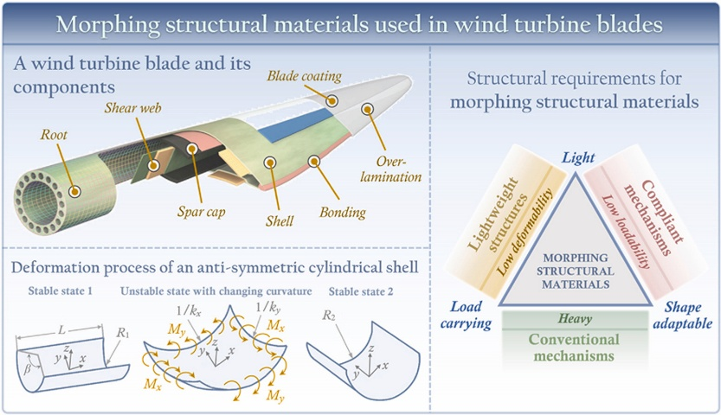
At the materials level, researchers are developing hybrid composite blades and using finite-element analysis to optimize aerodynamics and structural performance. Recent reviews report mass reductions of up to 30% for prototype blades. AI and IoT sensors are enabling predictive maintenance and structural health monitoring, which extends blade life and catches problems before they become expensive. [19](Figure 15)
Figure 15.Wind Blades design

Advances in energy storage
Storage is the piece that turns intermittent renewables into something a grid operator can actually rely on. The cost curve has been extraordinary. Lithium-ion battery pack costs fell from about US$1,415/kWh in 2008 to US$139/kWh in 2023, a 90% drop. [20]Over three decades, battery costs have fallen 99% while energy density increased fivefold. Each doubling of deployment has historically cut costs by about 19% and boosted energy density by around 7%. [21]
The next generation of solid-state batteries replaces flammable liquid electrolytes with solids, offering higher energy density and improved safety. They can deliver 8,000–10,000 charge cycles versus 1,500–2,000 for conventional lithium-ion, and they handle extreme temperatures better.^{[7]} Research into sodium-ion, zinc-based and iron-air chemistries promises even lower costs using more abundant materials. [20] Major automotive and electronics manufacturers are investing heavily in these technologies. [22]
According to Bloomberg NEF’s 2026 analysis, the levelized cost of a four-hour battery storage project fell by 27% in 2025 to US$78/MWh, down from over US$180/MWh at the start of the decade. That is not a minor adjustment. It is the kind of shift that makes fossil-fuel peaking plants increasingly difficult to justify. [23]

Grid integration and digitalization
Smart inverters, grid-forming controls and advanced weather forecasting allow renewable resources to provide frequency regulation and voltage support. Digital twins, AI-driven asset management and cloud-connected sensors let operators predict failures and optimize operations. Combined with falling storage costs, these tools reduce curtailment and make renewable power dispatchable in ways that were not practical five years ago.

Levelized cost of electricity (LCOE).
The levelized cost of electricity expresses the present value of all costs (building, operating, fueling and decommissioning a plant) divided by the total electricity it is expected to produce over its lifetime. The U.S. Department of Energy formula discounts future costs and energy output to present-value terms, so that a solar farm with a 25-year life and a gas plant with a 40-year life can be compared on equal footing.
The key inputs are capital costs, O&M costs, fuel costs, the discount rate, expected output and plant lifetime. LCOE is sensitive to the assumed capacity factor (actual output versus theoretical maximum), fuel and carbon prices, financing terms and policy incentives. Change the discount rate and a nuclear plant can look either competitive or ruinously expensive, which reveals how much uncertainty surrounds these projects. [24]

The efficiency of different renewable energy sources comparison:
Current LCOE ranges:
Renewable technologies. The numbers are striking. IRENA’s 2024 assessment found that 91% of new utility-scale renewable capacity added that year produced power cheaper than the cheapest fossil-fuel alternative, with global weighted-average LCOE hitting US$0.043/kWh for solar PV and US$0.034/kWh for onshore wind. [25] [13]
Table 2.LCOE Energy sources comparison
Technology | Estimated LCOE (2025) | Context
Onshore wind | ≈3.3 ¢/kWh (US$33/MWh) | Utility-scale in decent wind sites; about 35% capacity factor.
Solar PV | ≈4.4 ¢/kWh (US$44/MWh) | Down 90% since 2010; efficiency improvements continue.
Hydropower | ≈4.7 ¢/kWh (US$47/MWh) | Varies by site; long asset lifetimes.
Geothermal | ≈3.5 ¢/kWh (US$35/MWh) | Baseload power, but geographically constrained.
Offshore wind | ≈7.8 ¢/kWh (US$78/MWh) | Higher costs due to marine construction; falling as turbines scale.
Biomass | ≈8.0 ¢/kWh (US$80/MWh) | Fuel procurement and sustainability concerns keep costs elevated.
Solar + storage | ≈5.7 ¢/kWh (US$57/MWh) | Growing deployment; storage costs falling.

Bloomberg NEF’s 2026 report puts the benchmark LCOE for a typical fixed-axis solar farm at US$39/MWh in 2025, onshore wind at US$40/MWh and offshore wind at US$100/MWh. Battery storage projects reached a global benchmark LCOE of US$78/MWh. [23]
Conventional technologies. Fossil-fuel plants are still widely deployed, but their costs are heading the wrong direction. The same 2025 review estimates coal at roughly 11.2 ¢/kWh (US$112/MWh) and natural gas at 8.9 ¢/kWh (US$89/MWh). [13] Nuclear is harder to pin down. At high capacity factors and low discount rates, new nuclear can be US$27–61/MWh, but raise the discount rate to 10% and the figure rises to US$57–146/MWh. [14]

Factors that affect the efficiency of energy generation.
Two metrics are confused constantly, and it is worth separating them.
Thermal efficiency measures how effectively a plant converts fuel energy into electricity. In OECD (Organization for Economic Co-operation and Development) countries, coal plants average about 37% efficiency, while modern combined-cycle gas plants average around 45% and can exceed 60% in advanced designs. [26]Renewables sidestep this metric entirely because they convert natural energy directly, avoiding the thermodynamic losses that come with combustion.
Capacity factor is the ratio of actual energy output to maximum possible output. Nuclear leads here at over 90% because the plants run almost continuously. [27] Coal and natural gas typically manage 50–70%. Wind farms average around 35%, solar PV around 25%, and hydro varies with water supply. [28]
Lower capacity factors mean fixed costs are spread over fewer kilowatt-hours, which pushes LCOE up. For wind and solar, however, zero fuel costs can more than offset lower utilization. As storage and grid flexibility improve, the effective capacity factor of renewables continues to climb.
Evaluation:
Wind and solar are now often cheaper to build and operate than new fossil-fuel plants, even before environmental and health damage are priced in. Hydro and geothermal provide dispatchable baseload at low operating costs, though both are constrained by geography. Offshore wind remains more expensive but is falling rapidly as turbine sizes increase.
Fossil-fuel plants face high, volatile fuel costs and tightening emissions regulation. Gas offers moderate capital costs and fast ramping, but it still emits carbon dioxide and methane, and it is at the mercy of commodity markets. Coal is the most carbon-intensive source and is being phased out in many regions.

Describe the technologies used to generate renewable energy.

How technology is being used to generate renewable energy using solar, wind, water and biomass as fuels.
Technology is crucial to generation of renewable energy today. All of the types of renewable energy: Solar, wind, water and biomass are increasingly more efficient and productive as technology improves.

Solar Energy Generation Technologies:
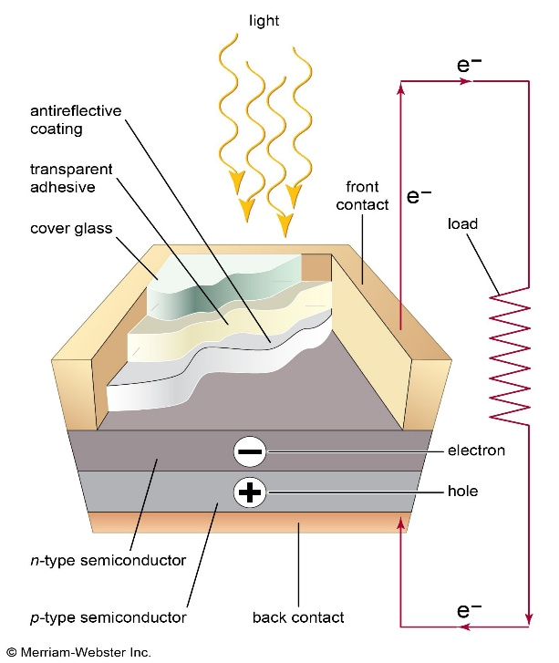
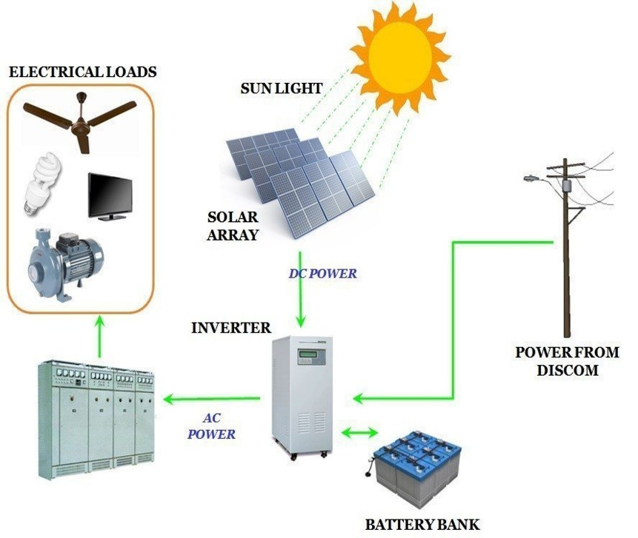
Can be harnessed more effectively using newer types of solar panels. When sunlight hits a PV solar cell, sunlight is absorbed by the semiconductor material (typically silicon) and the absorbed light energy creates excited electrons which form electron-hole pairs. The built-in electrical field across the p-n junction in the PV solar cell pushes the electrons (which have a negative charge) towards the positive terminal of the external electrical circuit and pushes the holes (which have a positive charge) in the opposite direction. In this process, the solar radiation is converted into direct current (DC) electricity. However, the DC current produced by the solar panels is not suitable for use in households or industries as they generally require current that is supplied in the form of alternating current (AC). However, this DC power can be easily changed into AC power with the help of an inverter, thus enabling the power generated from the solar radiation to be used in the grid as well. (Figure16)
Figure 16.Solar Energy Technology
Several advanced technologies are currently being developed in order to improve the conversion efficiency of solar energy as well as the costs of solar energy systems. These new technologies include the use of bifacial solar panels that can absorb the sunlight on both the front and back sides of the panels, perovskite solar cells, that have the potential to achieve higher conversion efficiency than traditional solar cells, while having lower production costs. Also, there are many improvements in the thin film solar energy technologies as well as concentrated solar power systems. All these new advanced technologies have helped in reducing the costs of installation and operation of the solar energy systems. The costs of the solar technologies have decreased significantly, and as a result, the generation of solar energy has become competitive with other forms of electricity generation that are produced from fossil fuels. Therefore, solar energy has become one of the cost effective forms of renewable energy systems that can be used worldwide. [29]

Wind Energy Generation Technologies:
Wind energy generation primarily relies on wind turbines, which convert the kinetic energy of wind into mechanical energy. The main components of a wind turbine consist of a rotor with blades, a nacelle, a tower and a generator. The rotor consists of blades, which have been designed in such a way as to maximize lift. When wind passes over the blades of the rotor, it forces them round in a circular motion. This mechanical energy is used to turn a shaft, which is connected to a gearbox, followed by the generator, which is usually located in the nacelle of the wind turbine. There are many different designs of wind turbines available, both onshore and offshore. Both designs are used in areas where the wind speed is high, such as coastal areas, and flat open spaces such as farms. (Figure 17).
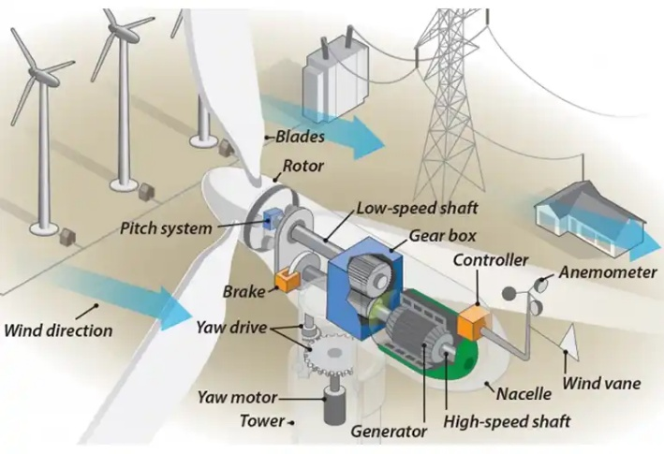
Figure 17.Wind Energy Technology
The effectiveness of wind energy varies from location to location, however. In addition to differing in terms of wind patterns, different locations also vary in terms of wind intensity. Regions characterized by consistent winds of considerable intensity, typically coastal regions and plains, can generate substantial amounts of energy using wind turbines. Countries such as Denmark and Germany have successfully integrated wind power into their power mix, at times reaching levels of 47% of all electricity generated within a country. Regions characterized by low levels of wind, which are unable to support the installation of large numbers of turbines, can turn to the use of hybrid systems or other sources of renewable energy in order to generate power and to ensure that energy is available at a moment when it is needed.
In addition to providing base-load power, wind power greatly contributes to the goal of providing energy to meet future demands by increasing the percentage of renewable energy to reduce carbon emissions. Renewable energy is being relied on more and more to help reduce our dependence on fossil fuels. In 2019, the wind power industry provided 7 % of global electricity. Wind energy is expected to continue to increase and become a larger percentage of global electricity in the coming years. Many governments are providing incentives for the installation of wind turbines and continued support of the wind industry will be essential for meeting future demands for energy and meeting renewable portfolio standards. [30]

Biomass Energy Generation Technologies:
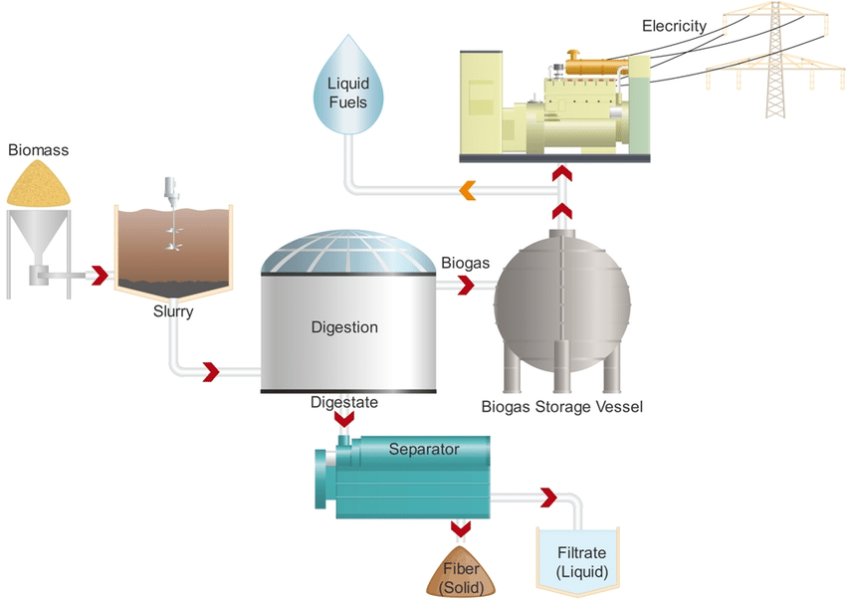
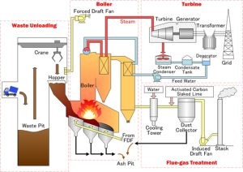
The various ways of using biomass for energy production are explained in more detail below. In Combustion or Incineration of Biomass, different types of biomass are burnt in order to produce steam in a boiler. Using this steam in a steam turbine will then generate electricity. Although the greenhouse gases that are released by this type of energy production have a negative impact on the climate, the emissions of carbon dioxide by burning of biomass are offset by the amount of carbon that has been fixed by the plants during their lifecycle (Figure 19). The other way of producing energy from biomass is by means of Anaerobic Digestion (Figure 18). In this process, organic materials are degraded in the absence of oxygen. Large amounts of biogas are produced during this process. The major components of this biogas are methane and carbon dioxide. The methane can be used for generating electricity and heat by means of gas engines or gas turbines. The produced gas also can be upgraded to renewable natural gas which can be injected into the natural gas grid.
Figure 18.Biomass Anaerobic Digestion
Figure 19.Biomass steam boiler
Biomass energy has the ability to be a highly efficient form of renewable energy, with some forms of biomass offering efficiencies of over 90%. However, the emissions from biomass combustion can be high and may even contribute to climate change, depending on the combustion method used and the feedstock being burned. However, when biomass is used for energy generation in a sustainable way, then the carbon that is released into the atmosphere during combustion is offset by the amount of carbon that has been fixed from the atmosphere by the plant during its growth. The efficiency of biomass energy conversion depends on the type of feedstock being used and the method of energy production. The production of electricity from biomass can offer an efficient and reliable method of energy generation that can be used to power homes, businesses, and industry, and can also be used to heat and power transportation. It can also be used as part of a wider strategy for reducing greenhouse gas emissions and for combating climate change. The use of biomass for energy can also offer a number of other benefits including the ability to dispose of waste materials in an environmentally friendly manner, to provide rural communities with income generating opportunities, and to improve energy security by providing a renewable alternative to fossil fuels. [31]

Water Energy Generation Technologies:
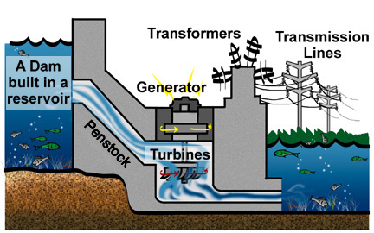
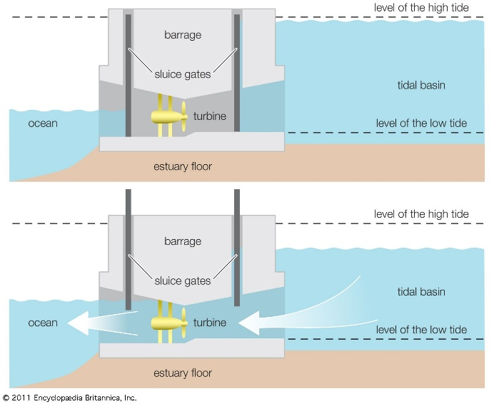
The energy is harvested from water is called water energy technologies. Here, the main sources of energy are hydro power (Figure 20) and tidal power (Figure 21) and both of these sources have experienced great development in recent years. Thus, there are now better designs for the turbines as well as more efficient ways for managing the water flow. All this has led to increased amount of electricity which is being produced from rivers and oceans. It is also known as renewable energy and is used in many parts of the world. The best example of renewable energy is hydro power and this is also the cleanest source of energy. Thus, it does not cause pollution and does not lead to any kind of environmental degradation. This is the reason why it is being used in many parts of the world for the production of electricity. [32] [33]
Figure 20.Hydo Power
Figure 21.Tidal Power
On the other hand, there are fewer risks of catastrophic failures and environmental pollution for renewable energy sources as they are based on natural processes, and the energy is captured using technology. Therefore, there are limited risks to human health and the environment. While there are many advantages of renewable energy sources, there are also some limitations as the power generation is not continuous. The power generated from variable sources of energy is not consistent and keeps fluctuating. For instance, solar power is not generated when it is cloudy or at night, whereas wind power is not generated when there is no wind. However, there are many smart solutions available, such as energy storage systems, to manage the variable power from renewable energy sources. In addition, geographical constraints of various resources limit the effectiveness of some renewable energy systems in certain locations.

The advantages and disadvantages of using nuclear fuel.
Nuclear fuel energy is a powerful source of energy which can be used to produce huge amounts of electricity to power the millions of people on Earth. As the planet moves forward in time there will obviously be a huge focus placed on the planet’s future and on finding sustainable sources of energy and so a look at the advantages and disadvantages of nuclear fuel energy is something that must be taken. Nuclear fuel energy has the good qualities of a sustainable source of energy and the bad qualities of posing a number of huge threats to the planet including the cost of the energy and the huge amounts of toxic waste it produces as well as the potential for a huge and devastating accident.
First, nuclear fuel energy is important because it can be a very powerful source of energy. It has advantages and disadvantages but that does not mean that we must disregard it because it is an important source of energy in the face of planet Earth’s future and that of sustainable energy. One of the advantages of nuclear energy is that there are a lot of good advantages especially in terms of sustainability. For instance, nuclear fuel energy has less carbon emissions than fossil fuel and it is very efficient because one nuclear power plant can give as much electricity as to power millions of households.
However, although nuclear energy is sustainable it is very expensive, particularly the construction of a nuclear plant. The initial outlay of funds for a nuclear power plant and its subsequent construction over a number of years can be more than a country or company wants to spend in order to generate electricity. In addition, the costs to run a nuclear power plant, including the protection of its employees, the maintenance of the plant, as well as the payment of all relevant licenses and the compliance with relevant regulations, will be very high as well.
Nuclear fuel also poses environmental risks especially from accidents in nuclear plants. Although the frequency of accidents in nuclear plants is relatively low, their effect is catastrophic, such as the Chernobyl accident in 1986 and the Fukushima accident in 2011. The accident in a nuclear plant releases radioactive materials that cause long-term effects on humans and the environment. The risk of serious accidents is one of the serious disadvantages of using nuclear fuel energy. However, this risk can be reduced by the strict implementation of safety measures and their protocols.
The disposal of nuclear waste is yet another very big problem with nuclear energy. The long lived radioactive materials that are made in the nuclear reactor as fuel is used up remain radioactive for thousands of years. This means that the Nuclear Power Plant will have to continue to deal with these very hazardous materials for a very long time after it ceases to generate electricity. In the meantime, most of the spent fuel from the reactor core is placed in temporary storage facilities on or near the site of the reactor. There is no perfect solution yet to dispose of the long lived radioactivity in Nuclear Waste. This problem is considered to be one of the major problems in the Nuclear Fuel Energy Industry today, and it has the potential to cause great harm for long periods of time, hence it is considered to be a major deterrent to the use of Nuclear Energy and thus is considered to be a major disadvantage for the use of Nuclear Fuel Energy.
In conclusion, it is important to recognize the good and the bad points of using nuclear fuel energy as a means of generating electricity. Like all forms of energy, nuclear has its pros and cons and its use will undoubtedly affect our environment, health, and the economy for many years to come. But hopefully, with an increase in nuclear facilities around the world, it will provide sustainable electricity for millions of people. Therefore, the world’s increasing population will be able to rely on a good source of clean, sustainable energy to satisfy their growing needs. [34]

End part 2.

Benefits and disadvantages of the use of renewable energy.
Introduction: The global energy sector is going through a fundamental transformation as nations strive for a carbon-free future, aiming to phase-out of fossil fuels albeit gradually, without jeopardizing their economic growth. This is because renewable energy sources are growing rapidly and have the potential to mitigate climate change's negative effects.
The interplay between different social and environmental factors, with the components of energy security, employment creation, and mitigation of carbon emissions each presenting benefits but also major costs (the capital expense required to build plants/leverage land infrastructure to collect energy as well as mitigating social instability which is one potential byproduct of industrialization) means that delving deeper into this research is a necessity.
This study's purpose is to provide a detailed evaluation of how the economies of global nations and the environment are changing with increasing renewable energy sources. Social, environmental and financial factors.

Investment costs:
It is important to note the costs associated with investing in renewable energy as these still present a significant economic barrier due to the high upfront capital cost involved with developing infrastructure, energy technology and installation in comparison to traditional fossil fuel systems. Though the upfront costs might deter households and small businesses, they provide considerable long-term value: near-zero fuel expenses, less maintenance requirements, and overall future savings. Public sentiment surrounding these expenses is often split; despite strong theoretical support for the long-run economic and environmental advantages, there remained the cost and hesitation to invest without guaranteed financial kickbacks — for example tax breaks or rebates. Some appraisal studies show that new renewable energy projects are now cheaper compared with fossil fuel alternatives in terms of life-cycle costs, yet a perception of high risk due to Volatility on interest rates and long payback periods continues to contribute towards low acceptance at domestic scale.
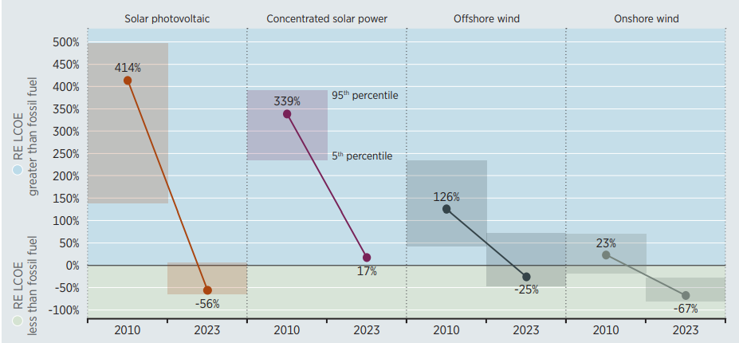
Figure 33, shows that after decades of declining costs and improved performance in solar and wind energy technologies, the economic benefits of renewable energy generation, along with its social, developmental, and environmental advantages, have become highly compelling. The global weighted average cost of onshore wind power was US$0.111/kWh. This was 23% higher in 2010 than the weighted average cost of new fossil fuel capacity additions, which was US$0.090/kWh. By 2023, the global weighted average cost of new onshore wind power had fallen to US$0.033/kWh, 67% lower than the weighted average cost of fossil fuels, which had risen to US$0.100/kWh. During the same period, the global weighted average cost of offshore wind power decreased from being 126% higher than the weighted average cost of fossil fuels to being 25% lower. The cost decreased from US$0.203/kWh to US$0.075/kWh. [35] (Figure 17)
Figure 22.LCOE for solar and wind compared to fossil fuels
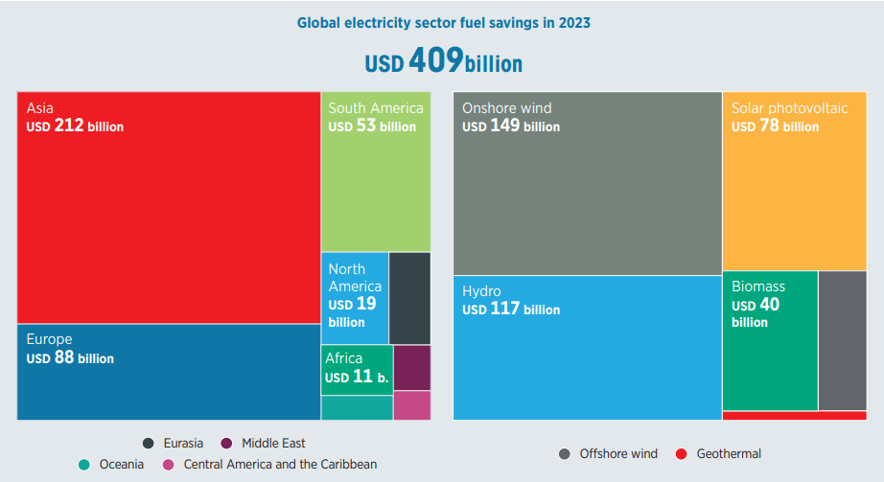
In 2023, the renewable power deployed globally since 2000 saved an estimated USD 409 billion in fuel costs in the electricity sector alone. [35] (Figure 18).
Figure 23.2023 Electricity Cost saving

Operating costs:
Renewable energy systems often have fewer mechanical components than traditional power plants, reducing the need for frequent repairs. Solar panels, for example, can last over 25 years with minimal servicing. This translates to lower maintenance costs, ensuring consistent energy production without the operational challenges associated with fossil fuel plants.
While some research [35] (Page 123) showed that some renewable energy like Offshore wind operation costs is higher than onshore due to specialized logistics and weather dependence, represent 16% to 25% of LCOE in G20 nations and are declining. Driven by improved strategies, competitive providers, and higher turbine ratings, annual operation and maintenance costs dropped from USD 82–151/kW in 2018 to USD 77–108/kW in 2023. IRENA analysis highlights significant reductions, with 2023 costs ranging from USD 0.022/kWh in China to USD 0.030/kWh in Europe, though newer markets face higher.

Disposal of waste products:
Renewable energy offers clean, sustainable power (solar, wind, hydro) with low emissions, economic growth, and reduced reliance on fossil fuels, but faces challenges like waste disposal from renewable technologies, such as:
Solar panels which have a 25-30 year lifespan. Recycling is possible but separating materials like silicon and glass is difficult and complicated.
The same for wind turbine blades which are made of complex composite materials that are difficult to recycle, often leading to landfill disposal, although new methods are in development.
While Lithium-ion batteries used for energy storage contain harmful materials, requiring complex, costly, and energy-intensive recycling processes. Generally, the production of renewable components can produce environmental pollution and hazardous waste. [36]

Pollution:
Renewable energy sources like solar, wind, and hydroelectric power fundamentally reduce pollution by eliminating the combustion of fossil fuels, which prevents the release of harmful air pollutants such as sulfur dioxide, nitrogen oxides, and particulate matter. These clean technologies offer the primary advantage of near-zero operational greenhouse gas emissions, significantly slowing global warming and improving public health by reducing respiratory and cardiovascular diseases. However, they are not entirely pollution-free; the manufacturing, transportation, and eventual disposal of components like solar panels and wind turbine blades create a "lifecycle" carbon footprint and pose waste management challenges. Despite these drawbacks, studies from organizations like the International Energy Agency (IEA) consistently show that the total environmental impact of renewables is vastly lower than that of coal, oil, or gas. [37] (Figure 19)
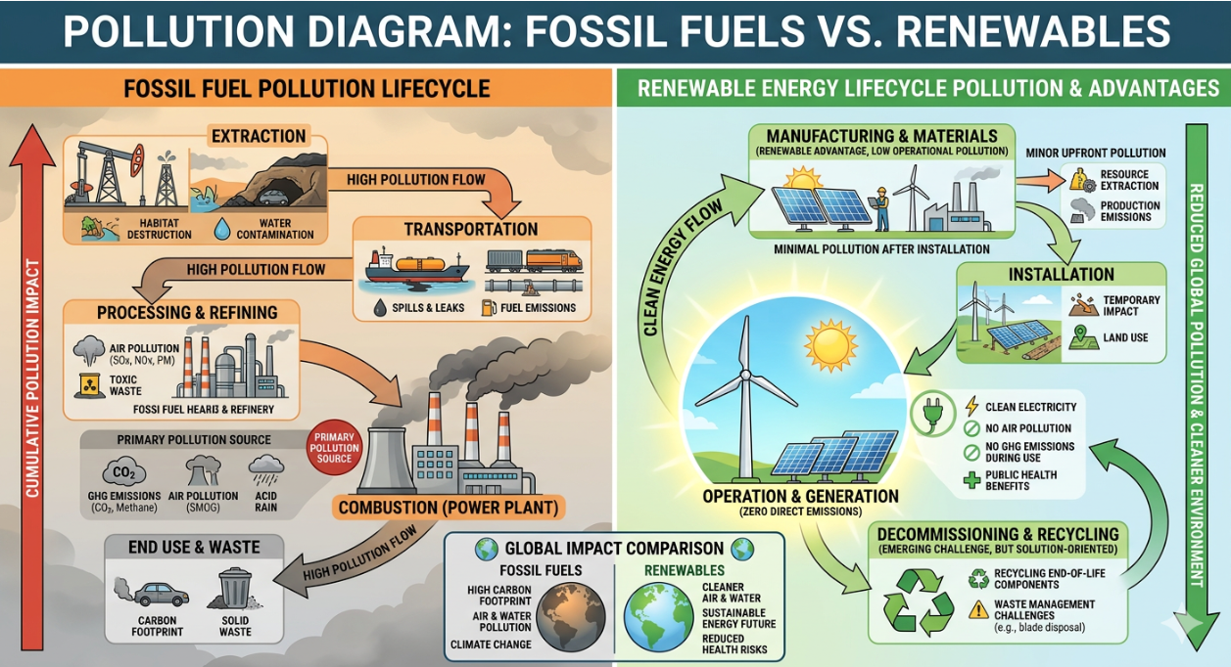
Figure 24. Fossil Vs. Renewables

Consistency/inconsistency of supply, storage of raw material
Consistency/inconsistency of supply: Renewable energy systems rely on natural resources such as sunlight, wind, and water, and therefore, their electricity generation can be as unpredictable as the weather. Solar panels lose efficiency on cloudy days, wind turbines aren’t effective in calm weather, and hydropower systems need consistent snow and rainfall to maintain reliable production. At the same time, when renewable systems produce too much energy, they risk overloading the grid and causing major problems for network operators. Australia, the country with the most solar panels per capita, is considering new export measures to prevent too much solar power from entering the grid on sunny days – and even charging system owners to do so. One of the advantages of non-renewable energy – such as the output from a coal power station – is a consistent flow of energy that can be ramped up and down. But the intermittency of renewables, combined with their accelerating deployment, requires many expensive infrastructure upgrades to maintain reliable supply which are ultimately paid for by the end users.
Storage of raw material: The storage of raw materials for renewable energy differs significantly from traditional fossil fuels. While fossil fuels require physical storage of coal, oil, or gas, (storage) for renewable energy often refers to either storing the resource (water, biomass) or storing the produced electricity (batteries, hydrogen) due to the intermittent nature of wind and solar. The inherent intermittency of renewable energy sources necessitates the integration of robust energy storage systems to facilitate the regulated capture and dispatch of electricity.
Lithium and flow batteries are key energy storage solutions and essential components for grid applications, despite challenges related to cost and raw material availability. Electrical energy storage methods, such as supercapacitors, offer rapid response but are limited by low energy density. Mechanical systems, including pumped hydroelectric and compressed air storage, excel in large-scale applications but face geographical limitations. Emerging chemical storage technologies, including hydrogen and synthetic natural gas, offer long-term solutions but require efficiency improvements. Thermal storage systems, such as molten salt storage and latent heat storage, show great potential for integrating renewable energy into heating and cooling, although material costs remain a barrier. Integrating hybrid systems demonstrates improved reliability and efficiency, highlighting the need to combine technologies to address the intermittent nature of renewable energy. Overall, the findings highlight the developments, challenges, and future research directions required for sustainable and scalable energy storage solutions. [38]

Efficiency:
The International Renewable Energy Agency report Renewable Power Generation Costs in 2023 shows that renewable power has become the cheapest option for new electricity generation in many regions and plays a key role in improving energy efficiency and reducing fuel dependence. Below highlights those renewable technologies are becoming more efficient, cost-competitive and socially beneficial, although there are still challenges that affect public perceptions and implementation. [35]
Social, Environmental and Financial Factors comparison
Table 3.Social,Environment and Financial efficiency
Factor | Advantages | Disadvantages
Social | Energy security, job creation, improved electricity access | Local opposition to projects, unequal economic benefits
Environmental | Reduced emissions, less pollution, climate protection | Land use impacts, resource extraction for technology
Financial | Lower electricity costs, fuel savings, declining technology costs | High initial investment, infrastructure upgrades needed

Impact of the installation.
While all energy generation impacts the environment, renewable technologies offer a cleaner alternative to emission-heavy fossil fuels, though they present serious challenges regarding land use, wildlife, and community aesthetics.
Land Use: Projects like solar and wind often require significantly more land per unit of energy than fossil fuel plants. [38]
Harm to wildlife: Turbines pose risks for migratory bird deaths and bats, Hydro dams as well block fish migration routes and cause high juvenile mortality. [39]
Change of habitat: Habitat loss and restoration impact the Earth system in a variety of ways, including species populations, ranges, biodiversity, and the interactions of organisms. Habitat loss can fragment ecosystems and can cause species extinctions, while habitat restoration can increase local biodiversity and species populations [40]
Needs for water: Solar panels require periodic washing, which can pollute water, while hydroelectric reservoirs can alter water temperature and oxygen levels.
Fertilizer/pesticides: Pesticides are often toxic to non-target organisms, including fish, birds, and beneficial insects, disrupting ecosystems as well overuse of fertilizers and pesticides damages soil health, leading to decreased microbial life, soil erosion, and acidification.
1.8 Noise and/or visual impact: Represent sensory environmental externalities that degrade landscape quality and well-being. These factors are increasingly pivotal in securing the social license required for large-scale industrial and energy projects. Noise disrupts animal communication and foraging, often leading to habitat abandonment among sensitive species like bats and marine mammals. Persistent noise exposure is linked to chronic stress, sleep deprivation, and measurable declines in public health and quality of life. [41]

The benefits and disadvantages/detrimental effects renewable energy sources:

Solar energy:
Benefits: Solar energy is a cornerstone of decarbonization because it produces zero emissions during operation and maintains a vastly lower carbon footprint than fossil fuels throughout its entire life cycle.
Solar energy plays a crucial role for saving electricity bills in residential and commercial and allow owners to sell excess power back to the grid, and create jobs in manufacturing, installation, and maintenance.
While the manufacturing and mining processes for photovoltaic components do involve some carbon output, these levels remain negligible compared to traditional energy sources. Research indicates that coal power releases roughly 25 times more greenhouse gases than solar, while natural gas produces about 10 times more, confirming solar as a far more sustainable and climate-friendly choice. [42]
Disadvantages/Detrimental Effects:
Despite the huge environmental and social benefits, it faces several critical hurdles, including intermittency issues that necessitate expensive battery storage for nighttime use and high upfront capital costs that can deter adoption. The technology also carries an environmental footprint, ranging from the energy intensive mining of raw materials and habitat disruption caused by large scale land use to the long-term challenge of managing toxic electronic waste as panels reach their end-of-life. Furthermore, operational efficiency can be compromised by environmental factors like dust, extreme heat, or shading, while the infrastructure for cost-effective, large-scale recycling is still in its developing stage. [42]

Wind energy.
Benefits: Wind energy has a critical role in fighting climate change. By significantly lower emissions of carbon dioxide and other harmful pollutants. Beyond environmental protection, wind energy fosters national energy independence and economic growth, becoming a cost free resource once the initial installation is complete. Because wind require minimal maintenance since it has fewer mechanical components than traditional power plants, reducing the need for frequent repairs and has an inexhaustible and globally abundant resource, it offers a permanent solution for sustainable development. [43]
Disadvantages/Detrimental Effects: While wind energy is increasingly more cost-competitive than fossil fuels and nuclear power, its economic viability still depends on regional wind speeds and continued technological innovation in manufacturing and physics to further drive down prices. A primary logistical hurdle is that the most productive wind sites are often remote, requiring significant grid upgrades and improved transmission networks to deliver power to high demand urban centers a challenge currently being addressed through better land-based and offshore interconnection capabilities. Additionally, the industry must navigate social and environmental concerns, specifically regarding the auditory and visual impact of turbines on the landscape. Finally, while wind power has a relatively low wildlife footprint compared to other energy sources, the sector remains focused on utilizing advanced siting techniques and ongoing environmental research to further minimize interactions with local ecosystem. [43]

Hydroelectric energy:
Benefits: Hydropower serves as a vital, emissions free energy source that actively mitigates climate change by replacing fossil fuel consumption and eliminating the release of harmful air pollutants. Because it harnesses the natural water cycle of rivers and streams, it provides an inexhaustible and renewable supply of power that is essentially permanent. A key environmental advantage is its low water footprint, as the water utilized for generation is not consumed but rather returned in its entirety to the ecosystem. This globally accessible resource empowers nations to achieve greater energy self-sufficiency and sustainable growth by reducing their dependence on imported raw materials. [44]
Disadvantages/Detrimental Effects: Sure enough, they are incredibly cost prohibitive to build, and the math on them gets better and better once you factor in extreme manufacturing standards. The very fact that the hydropower plant has to remain operational for several decades owing to huge construction costs, entirely relies upon water resources availability. When natural disasters cause floods, or dams break, they affect a wide area of land so the ecosystem can be affected. Specific area where a hydropower plant is going to be assembled people are forcibly removed. This has an impact on the daily life of individuals that reside in that region. Large dams have the potential to cause serious geological damage. The river gets block due to the reason fishes can’t reach their habitat and as water doesn’t flow, Riverside areas are getting disappear which finally affects life of animal kingdom who rely on fish as food.
Building hydropower plants is a complex and costly process that takes years of precise engineering and must adhere to high safety standards to recoup the decades of operation needed for costs to make sense which, in turn, relies on consistent levels of water availability. Aside from the enormous financial burden, those projects bear a great social and environmental cost with forced relocation of local populations and the threat that any dam failure could cause catastrophic flooding or geological damage. Additionally, river physical barriers impede aquatic ecosystems by blocking migration routes of fishes and drying out located downstream areas inducing collapse in local biodiversity as well as that on which it depends food webs. [44]

Biomass energy:
Benefits: Biomass serves as a vital tool in mitigating climate change because its combustion releases only the carbon that plants previously absorbed during their growth, creating a closed carbon cycle that contrasts sharply with the net-positive emissions of fossil fuels. By utilizing organic matter from agriculture, forestry, and aquaculture, this widely available energy source offers a far lower greenhouse gas profile than traditional hydrocarbons. Beyond energy production, biomass facilities help clean the environment by diverting massive amounts of municipal and industrial waste from landfills and waterways, where they would otherwise damage ecosystems. Transforming this waste into energy and biofertilizers provides a sustainable solution for a growing global population while simultaneously reducing the pollution that impacts human health. Ultimately, because it balances economic viability with environmental restoration, many experts view biomass as a premier renewable resource for a circular economy. [45]
Disadvantages/Detrimental Effects: The expansion of the biomass industry poses significant environmental and logistical risks, starting with the deforestation and habitat loss driven by intensive logging in regions, which destroys critical carbon sinks and threatens biodiversity. Despite being marketed as renewable, biomass combustion often yields a contested carbon neutrality, as it releases immediate greenhouse gas emissions. Beyond climate impacts, the process generates harmful air pollutants like PM2.5 that cause severe respiratory and cardiovascular health hazards, while the intensive cultivation of energy crops leads to water scarcity and soil degradation. Furthermore, the industry creates food security risks by diverting agricultural land and crops away from food production, which inevitably drives up global food prices. Economically, biomass remains hindered by its low energy density, which necessitates massive volumes of fuel and results in high transportation, storage, and capital investment costs compared to solar or wind. Finally, these facilities demand extensive land use and create operational burdens, such as the management and disposal of potentially toxic ash remnants. [46]

Geothermal energy:
Benefits: Geothermal energy offers a sustainable and efficient alternative to traditional fossil fuel power stations by significantly reducing the emissions of carbon dioxide and other toxic substances that drive climate change. Unlike intermittent renewable sources such as wind and solar, geothermal power remains constantly available, unaffected by weather or time of day, which allows for more predictable and programmable energy production. These plants are remarkably space efficient, requiring minimal surface land as most components are buried underground, and they operate with negligible noise levels once full capacity is reached. Beyond its high reliability and longevity with some plants lasting up to 100 years geothermal energy provides versatile domestic benefits, including the ability to both heat and cool homes while reducing overall energy consumption by up to 70%. Furthermore, technological innovations like low-enthalpy solutions are expanding the geographic viability of this resource, while bio-architecture is helping to integrate newer plants seamlessly into their natural surroundings. [47]
Disadvantages/Detrimental Effects: While geothermal energy is a powerful renewable resource, it presents distinct challenges such as induced seismic activity, where high-pressure water injection particularly in Enhanced Geothermal Systems can trigger tremors that risk structural damage and public concern. The extraction of vast quantities of underground fluids also risks land subsidence, necessitating complex management strategies like wastewater reinjection to prevent the ground from sinking. Furthermore, geothermal fluids often carry natural toxins like arsenic and mercury, which require stringent containment to avoid contaminating local water supplies or creating hazardous waste sludge. Though generally cleaner than fossil fuels, some plants still release trapped greenhouse gases and hydrogen sulfide, which can contribute to acid rain, while the industry remains hindered by high upfront drilling costs and the risk of dry wells. The technology's geographic limitations to tectonic boundaries and the potential for resource exhaustion mean that sites must be managed meticulously to ensure long-term thermal sustainability. [48]

Comparison of Nuclear Energy and Biofuels:
Table 4.Nuclear and Biofuels Energy Comparison
Category | Sub-Category | Nuclear Energy | Biofuels Energy
Social | Advantages | Generate high energy density which minimize footprint, drives economic growth through the creation of high paying, long term technical careers while simultaneously fortifying national energy security. | Supports agricultural economies and farmers. Provides energy independence for non-oil producing nations.
 | Disadvantages | Serious concerns regarding accidents (meltdowns) and long-term waste disposal lead to high social resistance. | Can drive up global food prices and threaten food security in poorer regions by diverting edible crops (corn, sugar) to fuel.
Environment | Advantages | Produces Zero emission during operation. It can run continually without weather dependence. | Theoretically closed carbon cycle as the crops absorbs CO₂ during growth. Essential for decarbonizing aviation and shipping.
 | Disadvantages | Radioactive Waste requires geological repositories and spent fuel remains hazardous for thousands of years. | Clearing forests for fuel crops can release carbon debts that take decades to repay. High water and pesticide usage.
Financial | Advantages | Electricity production is highly cost-effective due to long lifespan of plants (60–80 years). | Can be used in existing car engines and pipelines with little to no modification, saving on transition costs which is compatible with current infrastructure.
 | Disadvantages | Requires massive upfront investment (billions) and is prone to long construction delays and budget overruns. | High production costs compared to cheap solar or wind and depends on Highly dependent on government subsidies.

Evaluation:
When we consider the picture, we have to perceive how social, ecological and monetary components influence individuals and the planet. Because solar power does well with a various mix of different sources. With the social, environmental and financial issues facing us it appears a way to deliver renewable energy right now. That's because solar power has some benefits. It is scalable and cost effective, and the masses love it. Solar power, however, is not like those types of projects — nuclear and hydroelectric power plants are expensive. Solar energy can be installed quickly and easily, whether on building roofs like offices of farms factories, parking areas or large power plants. This makes it very flexible. It is also cheaper to generate energy from power, known as levelized cost of energy. Solar power is cheaper than coal in some places and it is poised to become the world’s fastest-growing source of electricity. People also love power because (aside from the way wind power can be messy) it doesn’t need us to move people the way hydroelectric does. It is also less dirty than nuclear energy. Although different energy sources can be a bit more consistent, offering energy when we want it solar energy is actually a very good option as it is cheap and low-volume of install. Powered by The Sun Solar power is the answer.

The advantages and disadvantages of renewable energy (Solar/Wind)
While renewable energy sources provide a viable trajectory toward global sustainability, their implementation necessitates a complex evaluation of divergent trade-offs across social, environmental, and economic sectors. The following analysis examines these multidimensional implications specifically regarding solar and wind energy systems. [49]
  - Solar Energy: Although solar photovoltaics offer significant potential for decentralized energy autonomy and low operational carbon emissions, their integration is often complicated by high initial capital expenditures, land-use competition with agricultural sectors, and the environmental challenges associated with the lifecycle management of photovoltaic materials. [49] [50]
Table 5.Solar V.s Wind Advantages/ Disadvantages
Factor | Advantages | Disadvantages
Social | Allows homeowners to generate their own power. Job Creation: High demand for local installers and technicians. | Land Use: Large-scale solar farms can compete with agricultural land or cultural sites.
Environmental | Produces no greenhouse gases during operation. Silent: Minimal noise pollution compared to other sources. | Waste Management: Solar panels contain hazardous materials and are currently difficult to recycle at scale.
Financial | Low Operating Costs: Once installed, the fuel (sunlight) is free. High Return on Investment: Significant long-term savings on electricity bills. | High Initial Investment: Upfront costs for panels and battery storage systems remain a barrier for many.

4.2 Wind Energy: Wind power serves as a highly efficient, scalable solution for large-scale carbon reduction; however, its deployment frequently encounters social resistance due to aesthetic and noise concerns (NIMBYism), alongside ecological risks pertaining to avian mortality and habitat fragmentation. [49] [50]
Table 6.Wind energy Social, Environmental and Financial
Factor | Advantages | Disadvantages
Social | Rural Development: Provides steady income to farmers/landowners who lease land for turbines. | Visual/Noise Pollution: Some communities object to the change in landscape and the "whooshing" sound of blades.
Environmental | Space Efficiency: The footprint of the turbine base is small, allowing farming to continue underneath. | Wildlife Impact: Turbines can pose a threat to birds and bats if not properly sited.
Financial | Cost Competitiveness: One of the cheapest forms of new electricity generation on a utility scale. | Intermittency: Requires expensive backup power or storage because wind doesn't always blow when demand is high.

4.3 Energy Systems Comparative Evaluation:
The determination of an optimal renewable energy source is fundamentally contingent upon geographical suitability and operational scale. A multidimensional assessment reveals distinct advantages and constraints across social, environmental, and financial paradigms.

4.3.1 Social Evaluation:
Solar Energy and Decentralization: Solar photovoltaics (PV) represent a highly accessible and democratic energy model. By facilitating residential installations, solar technology empowers individual stakeholders with direct autonomy over energy production.
Wind Energy and Rural Integration: Conversely, wind energy excels in multipurpose land utility. Unlike expansive solar arrays that may displace agricultural activity, wind turbines maintain a minimal ground footprint, allowing for a dual-revenue stream where landowners can sustain crop production concurrently with energy generation. [49]

4.3.2 Environmental Evaluation:
Lifecycle and Material Waste: Solar energy presents significant long-term waste management challenges. The complex chemical compositions and heavy metals inherent in PV panels complicate recycling processes more than the steel and fiberglass components of wind turbines.
Ecological Impact: Wind energy projects often entail a more pronounced immediate biodiversity footprint. Strategic siting is imperative to mitigate avian mortality, whereas solar installations once established typically pose fewer direct threats to migratory wildlife. [49]

4.3.3 Financial Evaluation:
Investment predictability: Solar power offers superior fiscal transparency for small-scale investors. The dramatic reduction in PV hardware costs has streamlined the calculation of Return on Investment for residential applications.
4.3.4 Utility scale efficiency: Wind energy remains the industry leader in cost-efficiency at the macro level. When evaluated by the Levelized Cost of Electricity (LCOE), large-scale wind farms frequently emerge as the most economical method for expanding grid capacity, provided the wind resource is consistent.
4.3.5 Conclusion:
Sign in to comment There may not be a magical answer when it comes renewable energy but we know what the optimal solution is: a blend of energy sources.
Thus, solar energy is better suited for overloaded and decentralized urban centers, whereas wind power (as with most other renewable sources) is predominantly efficient on an industrial scale. To mitigate the inherent limitation of variability (sunset and wind-famine), they both need to be matched with advanced battery storage or another renewable base-load source (such as geothermal, hydroelectric) in order to build a genuinely stable, carbon-free electricity grid.
End of part 3.

References

[1] | e. education, "energy education.ca," [Online]. Available: https://energyeducation.ca/encyclopedia/Coal.
[2] | e. education, "energyeducation.ca," [Online]. Available: https://energyeducation.ca/wiki/index.php?title=Special%3ASearch&search  =Oil+and+gas%3A+&go=Go.
[3] | globalenergymonitor.org, "globalenergymonitor.org," [Online]. Available: https://globalenergymonitor.org/press-release/oil-and-gas-  extraction-moves-offshore-in-2024/.
[4] | globalenergymonitor.org/, "globalenergymonitor.org," [Online]. Available: https://globalenergymonitor.org/.
[5] | N. I. o. E. H. Sciences, "National Institute of Environment Health Sciences," [Online]. Available: https://www.niehs.nih.gov/health/topics/agents/fracking#:~:text=Hydraulic%20fracturing%2C%20or%20fracking%2C%20is,release  %20natural%20gas%20or%20oil..
[6] | energyeducation.ca, "energyeducation.ca," [Online]. Available: https://energyeducation.ca/wiki/index.php?title=Special%3ASearch&search=Uses+of+oil%2C+coal+and+natural+gas&go=Go.
[7] | s. direct, "www.sciencedirect.com," [Online]. Available: https://www.sciencedirect.com/topics/agricultural-and-biological-sciences/  coal-tar#:~:text=Uses,Roberts.
[8] | U. I. Administration, "U.S.Energy Information Administration," [Online]. Available: https://www.eia.gov/energyexplained/oil-and-  petroleum-products/refining-crude-oil-inputs-and-outputs.php#:~:text=Petroleum%20refineries%20process%20crude%20oil,to%20  produce%20high%2Dvalue%20products..
[9] | IEA, "International Energy Agency," [Online]. Available: https://www.iea.org/energy-system/fossil-fuels.
[10] | G. M. asev, "link.springer.com," 2025. [Online]. Available: https://link.springer.com/article/10.1007/s40828-024-00200-4.
[11] | S. e. al, "www.cell.com," [Online]. Available: https://www.cell.com/iscience/fulltext/S2589-0042(24)02802-5.
[12] | L. I. R. M. D. N. a. G.-G. Santos, "www.cell.com," 2025. [Online]. Available: https://www.cell.com/iscience/fulltext/S2589-0042(24)  02802-5.
[13] | S. T. online, "Solar Tech online," 2025. [Online]. Available: https://solartechonline.com/blog/cost-of-renewable-energy-guide/.
[14] | W. N. Association, "Worl Nuclear Association," 2026 . [Online]. Available: https://world-nuclear.org/information-library/economic-  aspects/economics-of-nuclear-power.
[15] | D. Energy, "Digital Energy," [Online]. Available: https://www.digitalenergyby5.com/blog/is-renewable-energy-cheap-to-maintain/.
[16] | U. Nation, "United Nation," 2021. [Online]. Available: https://www.un.org/en/climatechange/raising-ambition/renewable-energy.
[17] | M. C. Portal, "MIT Climate Portal," [Online]. Available: https://climate.mit.edu/ask-mit/do-wind-turbines-kill-birds.
[18] | U. E. P. Agency, "U.S. Environmental Protection Agency," 2022. [Online]. Available: https://www.epa.gov/.
[19] | www.sciencedirect.com, "www.sciencedirect.com," [Online]. Available: https://www.sciencedirect.com/science/article/pii/  S1364032125002916.
[20] | EV.COM, "EV.COM," [Online]. Available: https://ev.com/news/u-s-doe-report-reveals-90-drop-in-lithium-ion-battery-costs-for-evs-  from-2008-to-2023.
[21] | rmi.org, "rmi.org," [Online]. Available: https://rmi.org/wp-content/uploads/dlm_uploads/2023/12/xchange_batteries_the_battery_  domino_effect.pdf.
[22] | www.monolithai.com, "www.monolithai.com," [Online]. Available: https://www.monolithai.com/blog/solid-state-batteries-energy-s  torage.
[23] | BloombergNE, "BloombergNE," [Online]. Available: BloombergNEF / pv magazine. (2026). Solar LCOE to fall 30% by 2035, says  BloombergNEF. Benchmark LCOE values..
[24] | U. D. o. Energy., "U.S. Department of Energy.," [Online]. Available: https://www.energy.gov/documents/lcoepdf.
[25] | www.irena.org/, "www.irena.org/," [Online]. Available: https://www.irena.org/Publications/2025/Jun/Renewable-Power-Generation-  Costs-in-2024.
[26] | I. E. Agency, "International Energy Agency," [Online]. Available: https://www.iea.org/reports/energy-efficiency-indicators-for-public-  electricity-production-from-fossil-fuels.
[27] | U. D. o. Energy, "U.S. Department of Energy Nuclear power," [Online]. Available: U.S. Department of Energy. (2022). Nuclear power  produces the most reliable electricity.
[28] | visualizingenergy.org, "visualizingenergy.org," [Online]. Available: https://visualizingenergy.org/what-are-capacity-factors-and-why-  are-they-important/.
[29] | "sciencedirect.com," [Online]. Available: https://www.sciencedirect.com/topics/engineering/solar-energy-system.
[30] | "www.sciencedirect.com," [Online]. Available: https://www.sciencedirect.com/topics/engineering/wind-turbine.
[31] | R. e. al, "ieabioenergy.com," 2021. [Online]. Available: https://www.ieabioenergy.com/wp-content/uploads/2022/04/IEA-Bioenergy-  Annual-Report-2021.pdf.
[32] | "www.sciencedirect.com," [Online]. Available: https://www.sciencedirect.com/topics/earth-and-planetary-sciences/tidal-power.
[33] | "www.sciencedirect.com," [Online]. Available: https://www.sciencedirect.com/topics/engineering/hydropower-plant.
[34] | M. a. M. Alwaeli, "www.mdpi.com," 2022. [Online]. Available: https://www.mdpi.com/1996-1073/15/12/4275.
[35] | F. L. Camera, "IRENA," [Online]. Available: https://www.irena.org/-/media/Files/IRENA/Agency/Publication/2024/Sep/IRENA_  Renewable_power_generation_costs_in_2023.pdf.
[36] | U. Nation, "United Nation," [Online]. Available: https://www.un.org/en/climatechange/raising-ambition/renewable-energy#:~:text=The%20upfront%20cost%20can%20be,environmental%20benefits%20of%20renewable%20energy..
[37] | IEA, "International Energy Agency," [Online]. Available: https://www.iea.org/reports/energy-access-and-air-pollution.
[38] | S. Direct, "Science Direct," [Online]. Available: https://www.sciencedirect.com/science/article/pii/S2542435124002447.
[39] | N. S. University, "NC State University," [Online]. Available: https://cnr.ncsu.edu/news/2019/11/renewable-energy-wildlife-conservation/.
[40] | S. Direct, "Science Direct," [Online]. Available: https://www.sciencedirect.com/topics/agricultural-and-biological-sciences/fossil-fuel.
[41] | E. Sustainability, "Energy Sustainability," [Online]. Available: https://energy.sustainability-directory.com/area/noise-and-visual-  pollution/resource/5/.
[42] | EART.ORG, "EART.ORG," [Online]. Available: https://earth.org/what-are-the-advantages-and-disadvantages-of-solar-energy/#:~:  text=5.,generated%20by%20a%20solar%20array..
[43] | globalbioenergy.org, "globalbioenergy.org," [Online]. Available: https://www.globalbioenergy.org/advantages-and-disadvantages-of-  renewable-energy/.
[44] | E. learning, "Enel.com learning," [Online]. Available: https://www.enel.com/learning-hub/renewables/hydroelectric-energy/advantages.
[45] | E. B. I. Association, "European Biomass Industry Association," [Online]. Available: https://www.eubia.org/cms/wiki-biomass/  employment-potential-in-figures/environmental-benefits/.
[46] | energyage, "energyage," [Online]. Available: https://www.energysage.com/about-clean-energy/biomass/pros-and-cons-biomass/.
[47] | e. learning, "enel.com learning," [Online]. Available: https://www.enel.com/learning-hub/renewables/geothermal-energy/advantages.
[48] | U. o. c. scientits, "Union of concerned scientits," [Online]. Available: https://www.ucs.org/resources/environmental-impacts-geothermal-energy#:~:text=Land%20subsidence%2C%20a%20phenomenon%20in,the%20risk%20of%20small%20earthquakes..
[49] | S. CENTRE, "sdewes.org," [Online]. Available: https://www.sdewes.org/jsdewes/pid9.0387#:~:text=In%20this%20study%2C%20the%  20literature,a%20proper%20environmental%20impact%20assessment...
[50] | U. D. O. ENERGY, "U.S. DEPARTMENT OF ENERGY," [Online]. Available:  https://www.energy.gov/cmei/articles/climate-and-air-quality-benefits-wind-and-solar-power-united-states#:~:text=Wind%20&%20solar%20energy%20provide%20air,on%20combustion%2Dbased%20electricity%20generation.  &text=Wind%20and%20solar%20energy%20provide,on%20.
[51] | W. E. Forum, "World Economic Forum," 2024. [Online]. Available: https://www.weforum.org/stories/2024/05/how-wind-energy-is-reshaping-the-future-of-global-power-and-politics/.
[52] | MDPI, "MDPI," 2025. [Online]. Available: https://www.mdpi.com/2073-4360/17/17/2339#Polymer_Composite_Systems_for_Wind_Turbine_Blades.
[53] | U. E. P. Agency, "U.S. Environmental Protection Agency," [Online]. Available: https://www.epa.gov/hw/solar-panel-frequent-questions#:~:text=The%20most%20common%20reason%20that,information%20on%20disposal%20and%20recycling..
[54] | "https://www.eesi.org," [Online]. Available: https://www.eesi.org.
[55] | "www.eesi.org," [Online]. Available: https://www.eesi.org/papers/view/fact-sheet-climate-environmental-and-health-impacts-of-fossil-fuels-2021#:~:text=Oil%20spills:%20Fossil%20fuel%20extraction,be%20up%20to%20$886.5%20billion..
[56] | NNAZA, "National Aeronautics and Space Administration," [Online]. Available: https://data.giss.nasa.gov/gistemp/graphs_v4/.
[57] | earth.org, "earth.org," [Online]. Available: https://earth.org/the-advantages-and-disadvantages-of-nuclear-energy/.

